**Dorian Dressler(eeu436)**This document aims to introduce the new functions added to the image class.  
The added functions are: Median Filter, Gaussian Filter, Laplacian Filter, Sobel Filter, Prewitt Filter, Sharpen, image segmentation, image blending and a histogram, as well NCC and SAE.  
The document further contains visual test data for each function.  
A critical evaluation is contained under point 2, code under point 3.  
Please note that the code section only contains the newly added functions.

Assignment 2

ICP 3038 – Computer vision

test Document

2016

**1. Tests:**

This section includes test images for the functions added to the image.cpp class.  
NCC and   
 NCC: SAE:  
- Laplacian Edge Detection 1.00132, 49789  
- Prewitt Edge Detection -0.0519489 1.11368e+07  
- Sobel Edge Detection 0.996511 3.69748e+06  
- Box Blur 1.0005 267743  
- Gaussian Blur 0.906742 1.36636e+07  
- Median Filter 0.995457 176000  
- Image sharpening 0.565888 1.10934e+07  
- Threshold segmentation 0.0892192 2.3348e+08  
- Image blending

Laplacian Edge Detection:

Input:

Output:  
  
imageJ:

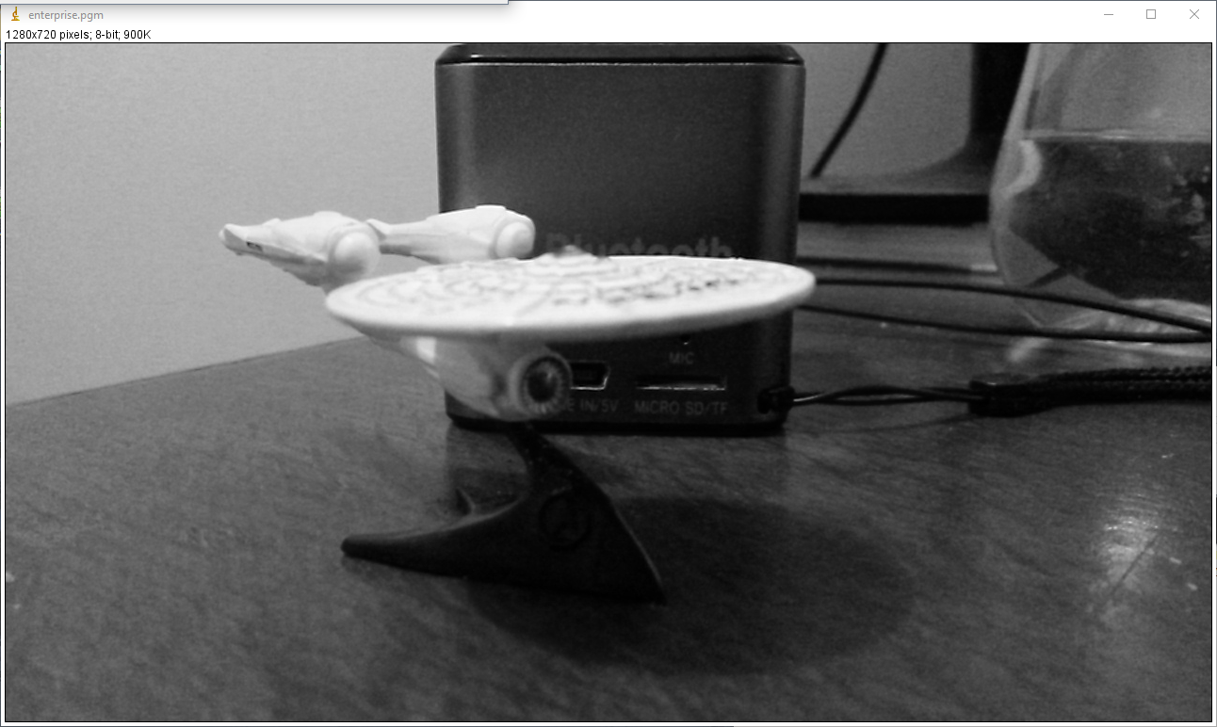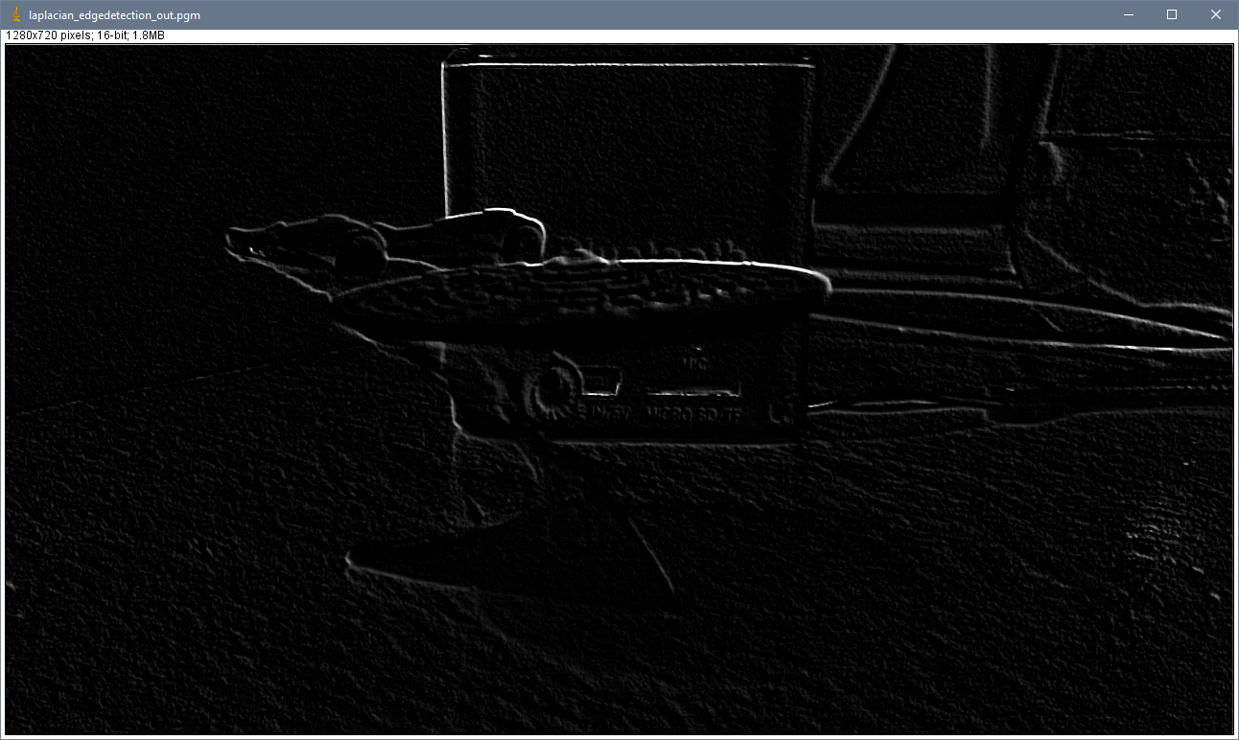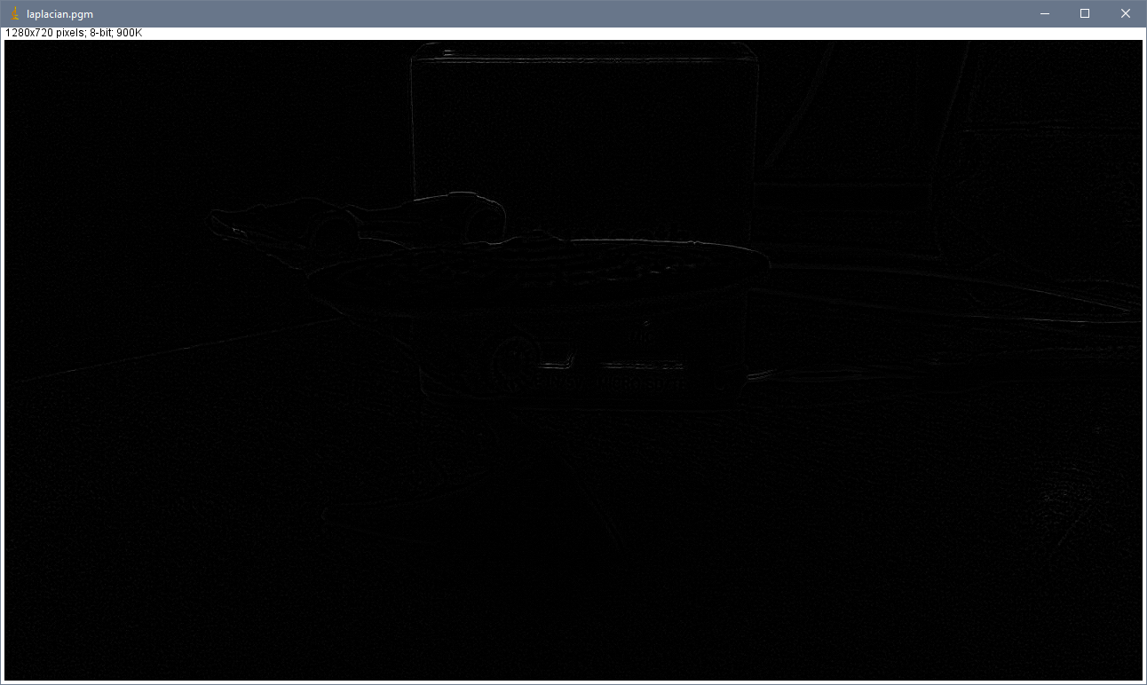

Prewitt Edge Detection:  
Input: as above  
  
Output:  
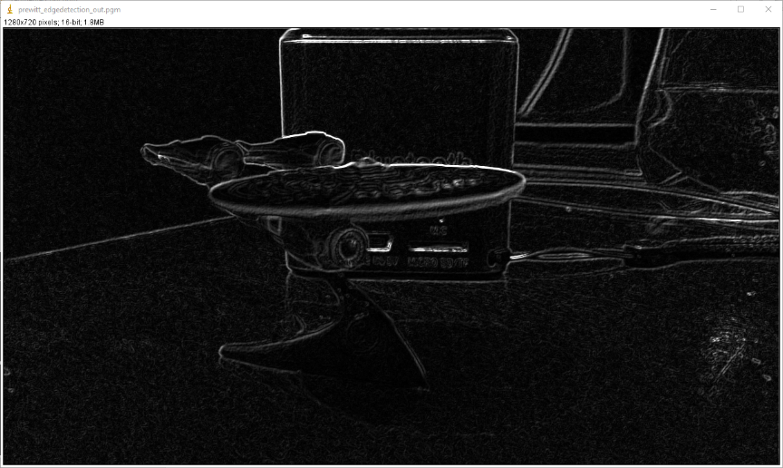  
  
imageJ:

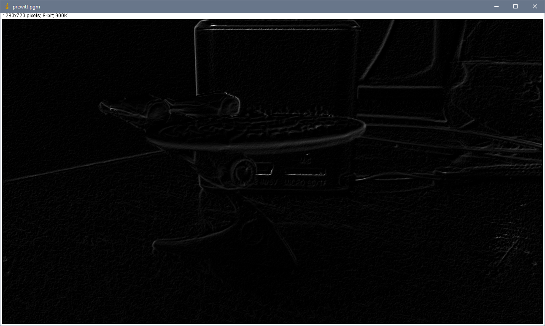

Sobel Edge Detector:  
  
Input: as above  
  
Output:  
  
  
imageJ:

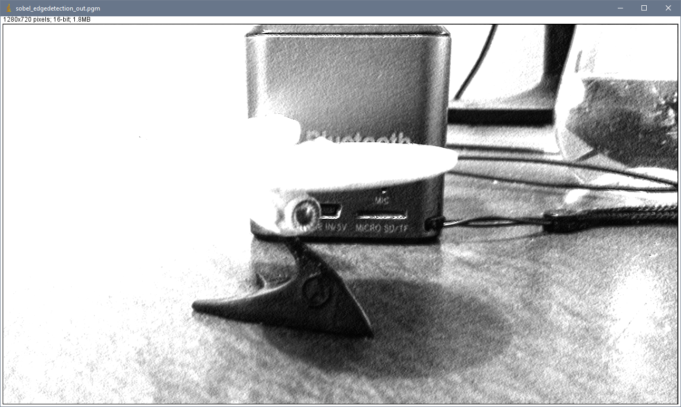

Box Blur:  
Input:  
  
  
Output:

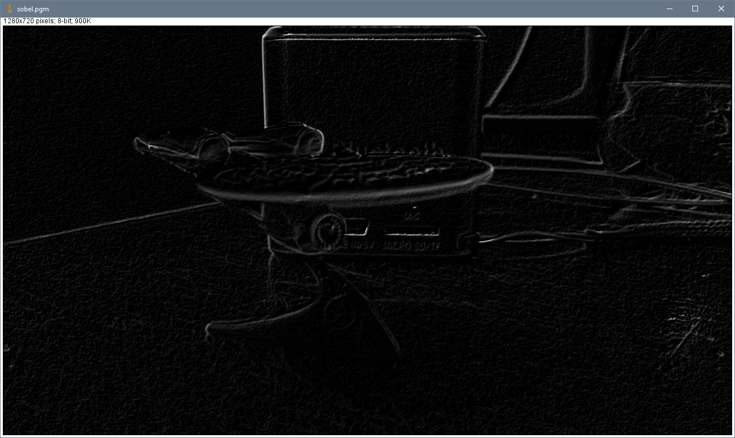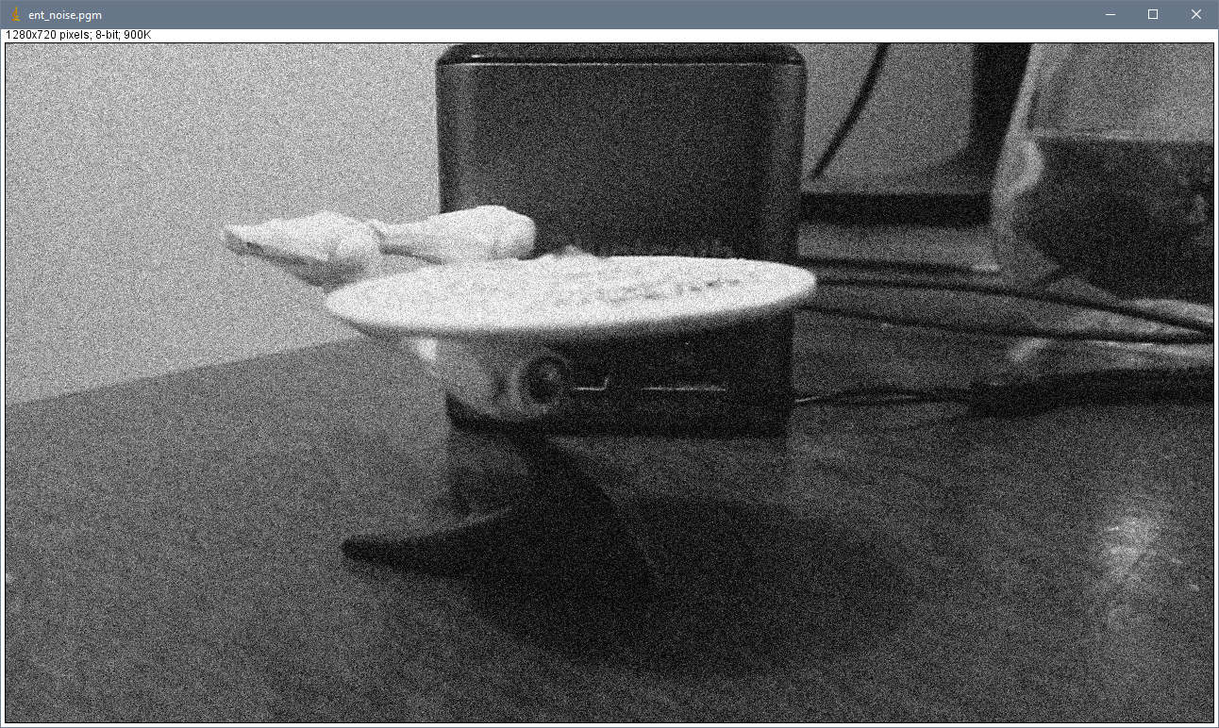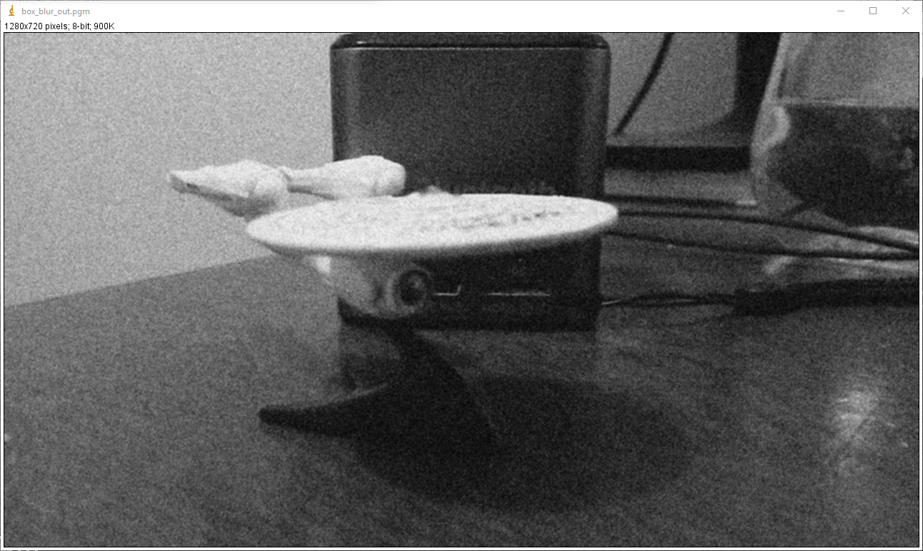

imageJ:  
  
  
  
Gaussian Blur:  
Input: as above.  
Output:  
  
imagej:  
  
  
  
  
  
  
  
  
  
  
Median Filter:  
Input: as above  
  
Output:  
  
  
imageJ:

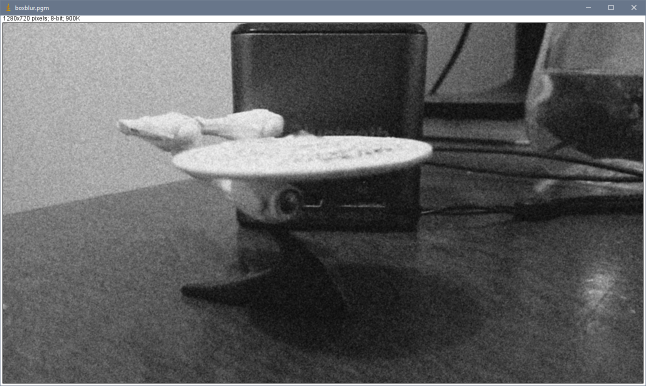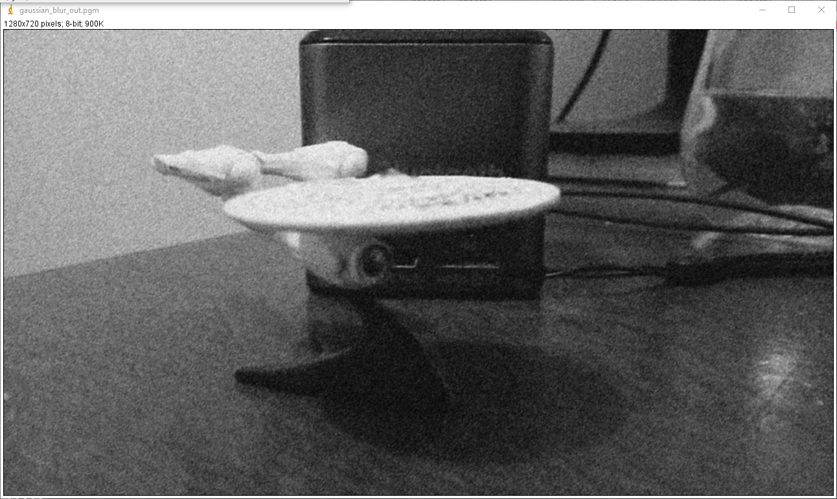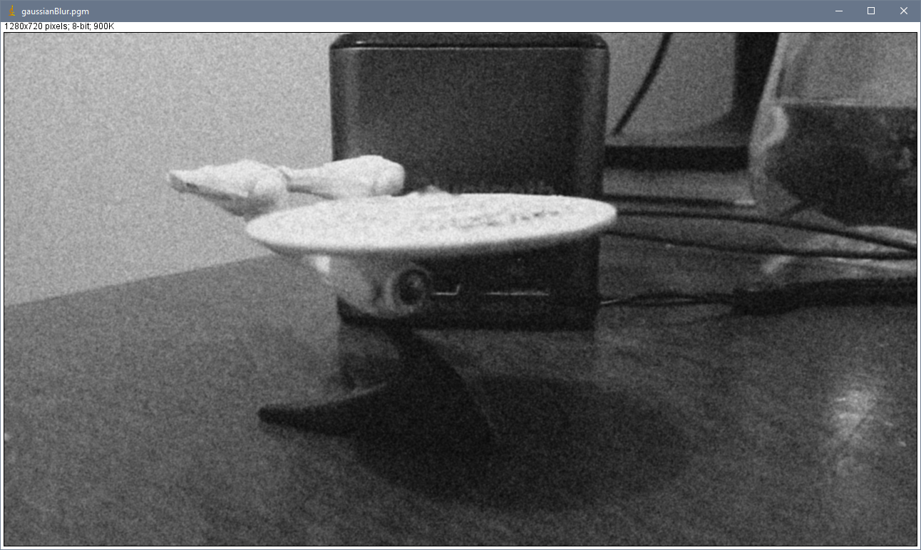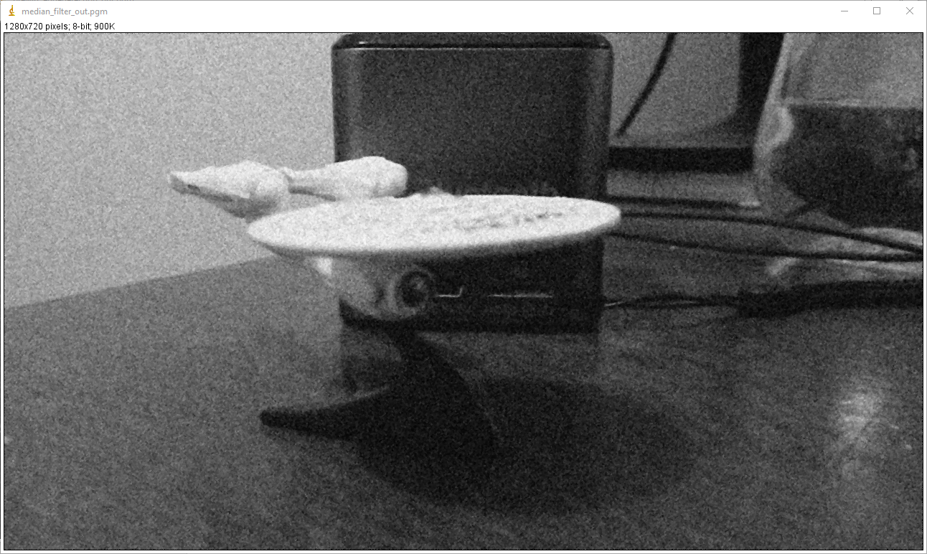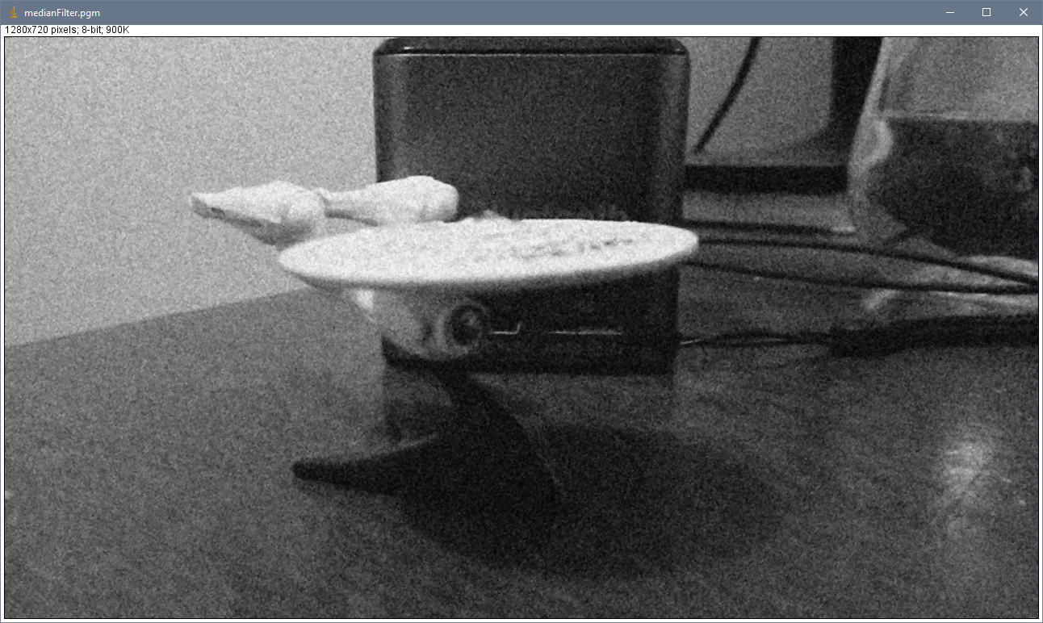

Image sharpening:  
Input:  
  
Output:  
  
imageJ:

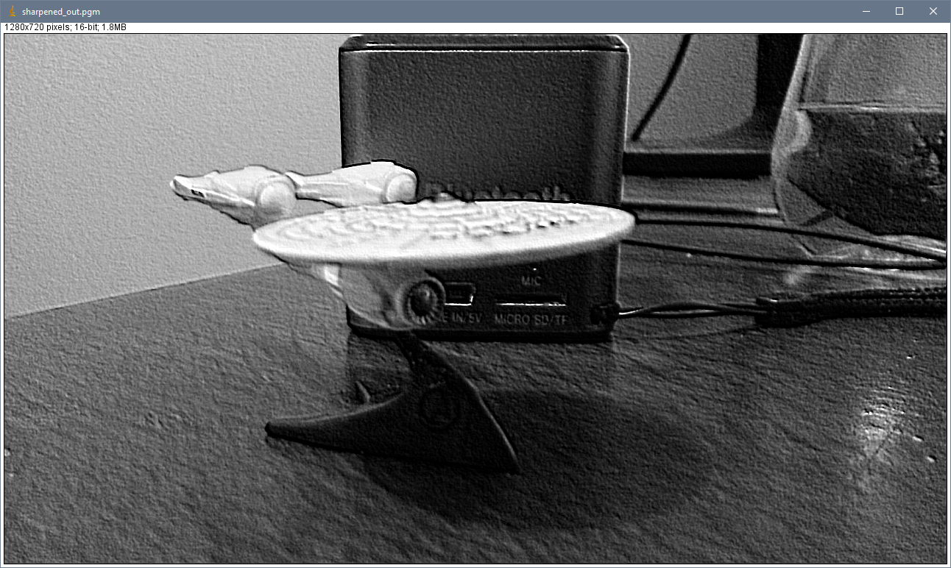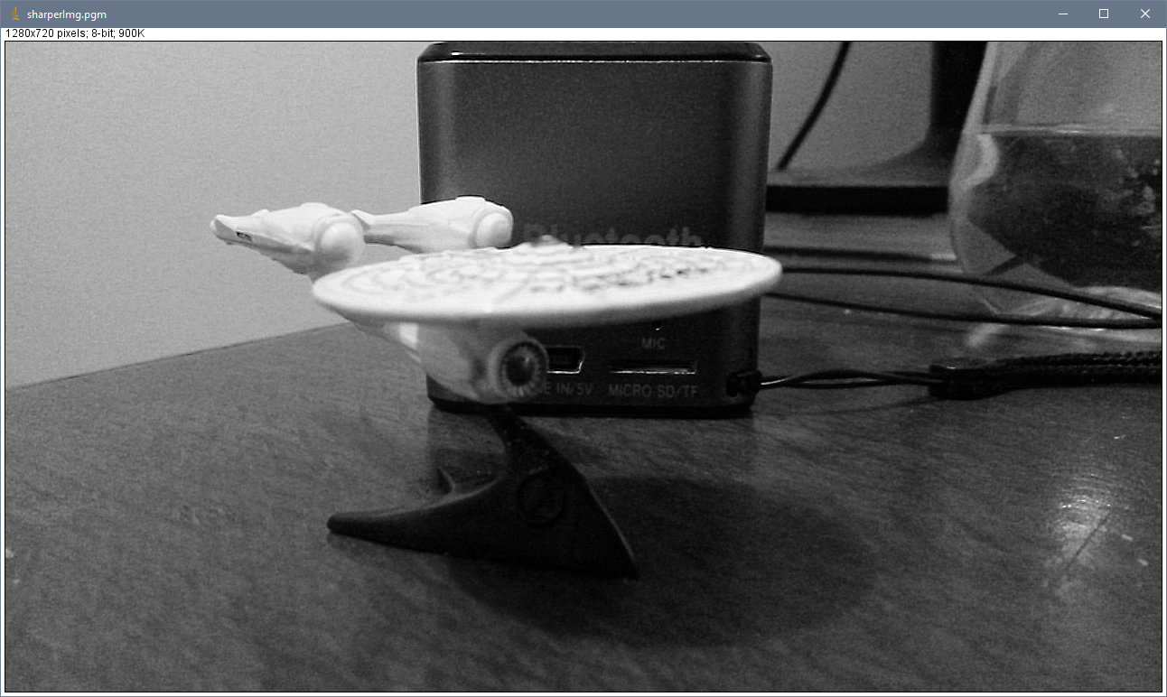

Threshold segmentation: **Threshold@125**Input:  
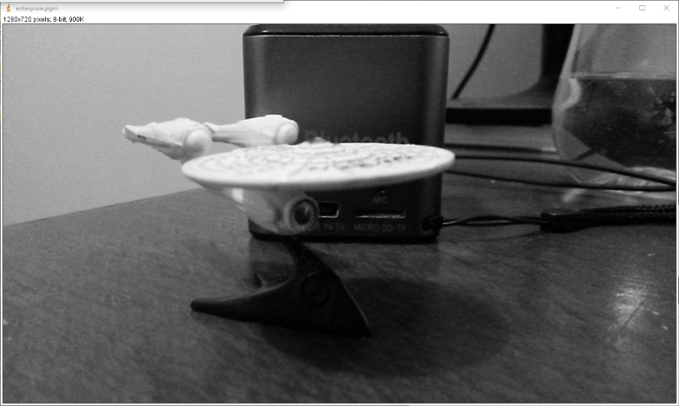  
Output:  
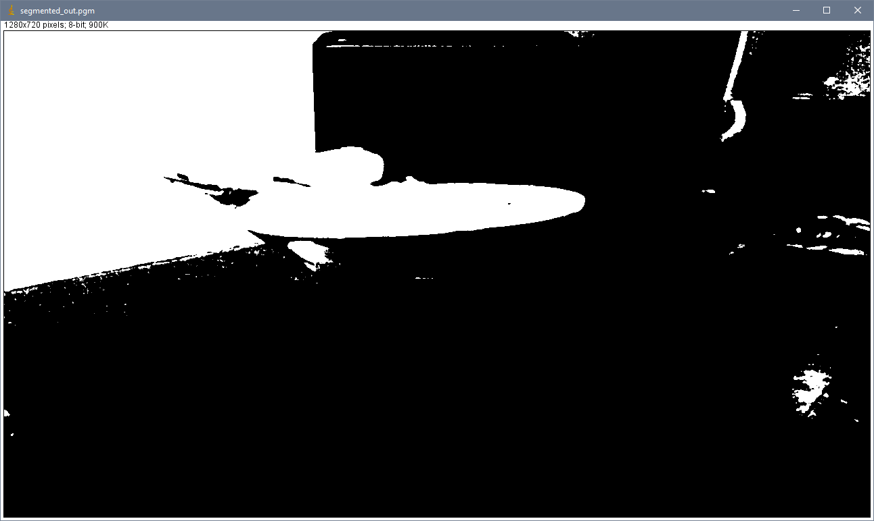  
imageJ:  
  
  
Image blending: 2 images, 512x512, Ratio: 50%Input:  
   
  
Output:   
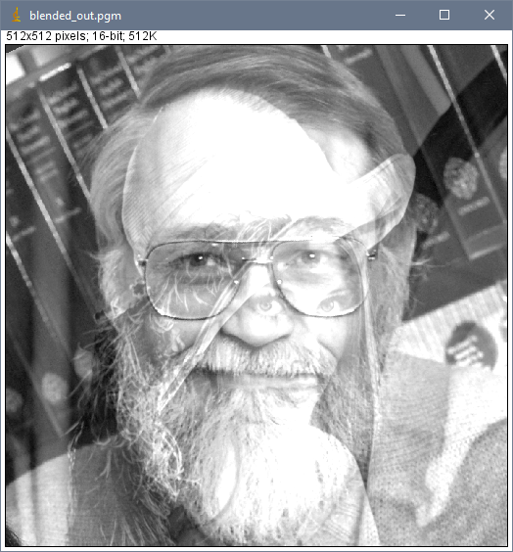  
  
  
  
  
  
  
  
  
  
  
  
  
  
  
  
**2. Critical Evaluation:**

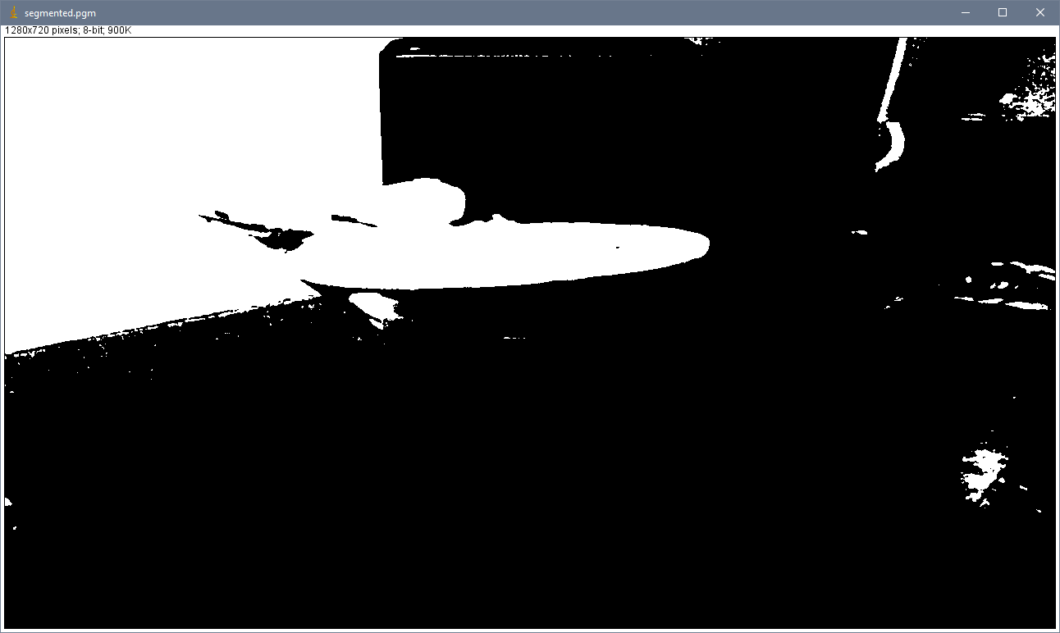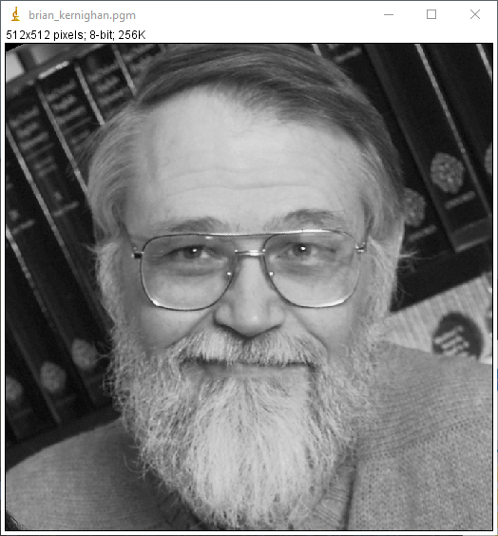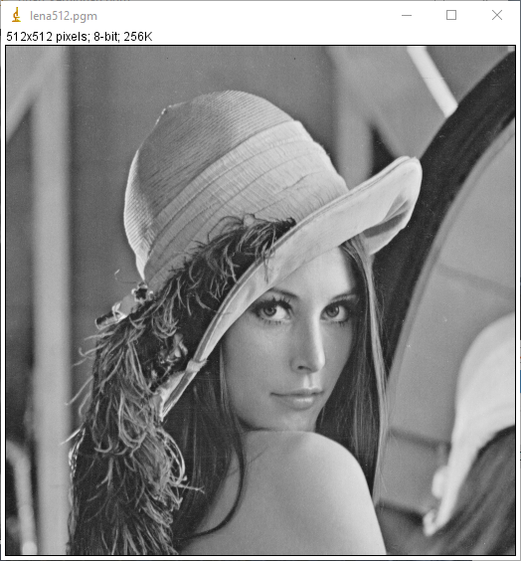

In its entirety, I was not able to implement all functions satisfactorily.   
The NCC value based tests failed for each function I implemented, however this may be due to errors in generating the imageJ files using the kernels provided.  
The output for the Laplacian Edge Detection I implemented looks better than the Laplacian I generated with imageJ. It is however noteworthy that my implementation did not achieve to highlight all edges, when compared to the original image. Similar issues arose for the Prewitt Edge Detection. My class’ output highlights edges much stronger and much more clearly. By contrast, imageJ’s results fail to highlight some of the vertical lines, for instance the right edge of the Bluetooth speaker in the background. The Sobel Edge Detector kernel failed to work in my class, I strongly suspect I might have missed a line of code or used the wrong kernel. This is evident, as the edge detector does not actually detect edges. The same applies to the Gaussian Blur and the Median Filter. Image.cpp sharpening function sharpens the image quite drastically, as can be seen by the wooden surface. ImageJ’s built in function creates a much smoother result. This is probably because I did not implement a way to allow the user to determine the intensity of the sharpening filter.  
Both threshold segmentation functions deliver very similar visual results.  
The box blur seems to work okay, as I cannot visually detect a vast difference between imageJ and my function. Image blending seems to work fine.  
  
Altogether, I feel that I could’ve cleaned up my code a lot more and found a better solution for defining edge cases, but the functions work, despite their limitations.

**3. Code**/**

********************************************************************************

*

* @file test2.cpp

*

* @brief Tests for: getSAE, getNCC, image blending,threshold segmentation,

* median filter, sobel filter, prewitt filter, laplacian filter,

* box blur.

*

* @version 1.0

*

* @date 23/12/2016

*

* @author Dorian Dressler

*

*

********************************************************************************

*/

//******************************************************************************

// Include

//******************************************************************************

#include <sstream>

#include <iostream>

#include <exception>

#include "Image.h"

//-----------------------------

int main(int argc, char** argv)

//-----------------------------

{

// Return code

int error_code(0);

// Catch exceptions

try

{

// Load an image

Image input_1, input_2, input_3, input_4;

input_1.loadPGM("C:\\Users\\Mepnomon\\Desktop\\CV Assignment 2\\test_data\\enterprise.pgm");

input_2.loadPGM("C:\\Users\\Mepnomon\\Desktop\\CV Assignment 2\\test_data\\brian_kernighan.pgm");

input_3.loadPGM("C:\\Users\\Mepnomon\\Desktop\\CV Assignment 2\\test_data\\lena512.pgm");

input_4.loadPGM("C:\\Users\\Mepnomon\\Desktop\\CV Assignment 2\\test_data\\ent_noise.pgm");

//load reference images

Image ref_1, ref_2, ref_3, ref_4, ref_5, ref_6, ref_7, ref_8;

ref_1.loadPGM("C:\\Users\\Mepnomon\\Desktop\\CV Assignment 2\\test_data\\Reference\\medianFilter.pgm");

ref_2.loadPGM("C:\\Users\\Mepnomon\\Desktop\\CV Assignment 2\\test_data\\Reference\\laplacian.pgm");

ref_3.loadPGM("C:\\Users\\Mepnomon\\Desktop\\CV Assignment 2\\test_data\\Reference\\gaussianBlur.pgm");

ref_4.loadPGM("C:\\Users\\Mepnomon\\Desktop\\CV Assignment 2\\test_data\\Reference\\boxblur.pgm");

ref_5.loadPGM("C:\\Users\\Mepnomon\\Desktop\\CV Assignment 2\\test_data\\Reference\\sharperImg.pgm");

ref_6.loadPGM("C:\\Users\\Mepnomon\\Desktop\\CV Assignment 2\\test_data\\Reference\\segmented.pgm");

ref_7.loadPGM("C:\\Users\\Mepnomon\\Desktop\\CV Assignment 2\\test_data\\Reference\\prewitt.pgm");

ref_8.loadPGM("C:\\Users\\Mepnomon\\Desktop\\CV Assignment 2\\test_data\\Reference\\sobel.pgm");

//test output

Image medianFilteredImage;

medianFilteredImage = input_4.selectFunction_3x3(0);

medianFilteredImage.savePGM("C:\\Users\\Mepnomon\\Desktop\\CV Assignment 2\\test_data\\results\\median_filter_out.pgm");

medianFilteredImage.saveASCII("C:\\Users\\Mepnomon\\Desktop\\CV Assignment 2\\test_data\\results\\median_filter_out.ascii");

medianFilteredImage.saveRaw("C:\\Users\\Mepnomon\\Desktop\\CV Assignment 2\\test_data\\results\\median_filter_out.raw");

std::cout << (std::abs(medianFilteredImage.getNCC(ref_1) - 1.0) < 1.0e-3 ? "SUCCESS" : "FAILURE") << std::endl;

std::cout << abs(medianFilteredImage.getSAE(ref_1)) << std::endl;

Image laplacianFilterImage;

laplacianFilterImage = input_1.selectFunction_3x3(1);

laplacianFilterImage.savePGM("C:\\Users\\Mepnomon\\Desktop\\CV Assignment 2\\test_data\\results\\laplacian_edgedetection_out.pgm");

laplacianFilterImage.saveASCII("C:\\Users\\Mepnomon\\Desktop\\CV Assignment 2\\test_data\\results\\laplacian_degedetection_out.ascii");

laplacianFilterImage.saveRaw("C:\\Users\\Mepnomon\\Desktop\\CV Assignment 2\\test_data\\results\\laplacian_edgedetection_out.raw");

std::cout << (std::abs(laplacianFilterImage.getNCC(ref_2) - 1.0) < 1.0e-3? "SUCCESS" : "FAILURE") << std::endl;

std::cout << abs(laplacianFilterImage.getSAE(ref_2)) << std::endl;

Image gaussianBlurImage;

gaussianBlurImage = input_4.selectFunction_3x3(2);

gaussianBlurImage.savePGM("C:\\Users\\Mepnomon\\Desktop\\CV Assignment 2\\test_data\\results\\gaussian_blur_out.pgm");

gaussianBlurImage.saveASCII("C:\\Users\\Mepnomon\\Desktop\\CV Assignment 2\\test_data\\results\\gaussian_blur_out.ascii");

gaussianBlurImage.saveRaw("C:\\Users\\Mepnomon\\Desktop\\CV Assignment 2\\test_data\\results\\gaussian_blur_out.raw");

gaussianBlurImage.getSAE(input_4);

std::cout << (std::abs(gaussianBlurImage.getNCC(ref_3) - 1.0) < 1.0e-3 ? "SUCCESS" : "FAILURE") << std::endl;

std::cout << abs(gaussianBlurImage.getSAE(ref_3)) << std::endl;

Image boxBlurImage;

boxBlurImage = input_4.selectFunction_3x3(3);

boxBlurImage.savePGM("C:\\Users\\Mepnomon\\Desktop\\CV Assignment 2\\test_data\\results\\box_blur_out.pgm");

boxBlurImage.saveASCII("C:\\Users\\Mepnomon\\Desktop\\CV Assignment 2\\test_data\\results\\box_blur_out.ascii");

boxBlurImage.saveRaw("C:\\Users\\Mepnomon\\Desktop\\CV Assignment 2\\test_data\\results\\box_blur_out.raw");

std::cout << (std::abs(boxBlurImage.getNCC(ref_4) - 1.0) < 1.0e-3 ? "SUCCESS" : "FAILURE") << std::endl;

std::cout << abs(boxBlurImage.getSAE(ref_4)) << std::endl;

Image sharperImage;

sharperImage = input_1.selectFunction_3x3(4);

sharperImage.savePGM("C:\\Users\\Mepnomon\\Desktop\\CV Assignment 2\\test_data\\results\\sharpened_out.pgm");

sharperImage.saveASCII("C:\\Users\\Mepnomon\\Desktop\\CV Assignment 2\\test_data\\results\\sharpened_out.ascii");

sharperImage.saveRaw("C:\\Users\\Mepnomon\\Desktop\\CV Assignment 2\\test_data\\results\\sharpened_out.raw");

std::cout << (std::abs(sharperImage.getNCC(ref_5) - 1.0) < 1.0e-3 ? "SUCCESS" : "FAILURE") << std::endl;

std::cout << abs(sharperImage.getSAE(ref_5)) << std::endl;

Image segmentedImage;

segmentedImage = input_1.segmentImage(125);

segmentedImage.savePGM("C:\\Users\\Mepnomon\\Desktop\\CV Assignment 2\\test_data\\results\\segmented_out.pgm");

segmentedImage.saveASCII("C:\\Users\\Mepnomon\\Desktop\\CV Assignment 2\\test_data\\results\\segmented_out.ascii");

segmentedImage.saveRaw("C:\\Users\\Mepnomon\\Desktop\\CV Assignment 2\\test_data\\results\\segmented_out.raw");

std::cout << (std::abs(segmentedImage.getNCC(ref_6) - 1.0) < 1.0e-3 ? "SUCCESS" : "FAILURE") << std::endl;

std::cout << abs(segmentedImage.getSAE(ref_6)) << std::endl;

Image blendedImage; //x

blendedImage = input_2.blendImage(input_3, 0.5);

blendedImage.savePGM("C:\\Users\\Mepnomon\\Desktop\\CV Assignment 2\\test_data\\results\\blended_out.pgm");

blendedImage.saveASCII("C:\\Users\\Mepnomon\\Desktop\\CV Assignment 2\\test_data\\results\\blended_out.ascii");

blendedImage.saveRaw("C:\\Users\\Mepnomon\\Desktop\\CV Assignment 2\\test_data\\results\\blended_out.raw");;

Image prewittImage; //x

prewittImage = input_1.selectFunction_3x3(5);

prewittImage.savePGM("C:\\Users\\Mepnomon\\Desktop\\CV Assignment 2\\test_data\\results\\prewitt_edgedetection_out.pgm");

prewittImage.saveASCII("C:\\Users\\Mepnomon\\Desktop\\CV Assignment 2\\test_data\\results\\prewitt_edgedetection_out.ascii");

prewittImage.saveRaw("C:\\Users\\Mepnomon\\Desktop\\CV Assignment 2\\test_data\\results\\prewitt_edgedetection_out.raw");

std::cout << (std::abs(prewittImage.getNCC(ref_7) - 1.0) < 1.0e-3 ? "SUCCESS" : "FAILURE") << std::endl;

std::cout << abs(prewittImage.getSAE(ref_7)) << std::endl;

Image sobelImage; //x

sobelImage = input_1.selectFunction_3x3(6);

sobelImage.savePGM("C:\\Users\\Mepnomon\\Desktop\\CV Assignment 2\\test_data\\results\\sobel_edgedetection_out.pgm");

sobelImage.saveASCII("C:\\Users\\Mepnomon\\Desktop\\CV Assignment 2\\test_data\\results\\sobel_edgedetection_out.ascii");

sobelImage.saveRaw("C:\\Users\\Mepnomon\\Desktop\\CV Assignment 2\\test_data\\results\\sobel_edgedetection_out.raw");

//sobelImage.getNCC(input_1);

std::cout << (std::abs(sobelImage.getNCC(ref_8) - 1.0) < 1.0e-3 ? "SUCCESS" : "FAILURE") << std::endl;

std::cout << abs(sobelImage.getSAE(ref_8)) << std::endl;

}

// An error occured

catch (const std::exception& error)

{

error_code = 1;

std::cerr << error.what() << std::endl;

}

catch (const std::string& error)

{

error_code = 1;

std::cerr << error << std::endl;

}

catch (const char* error)

{

error_code = 1;

std::cerr << error << std::endl;

}

catch (...)

{

error_code = 1;

std::cerr << "Unknown error" << std::endl;

}

return (error_code);

}

**/\*\***

**\*\*\*\*\*\*\*\*\*\*\*\*\*\*\*\*\*\*\*\*\*\*\*\*\*\*\*\*\*\*\*\*\*\*\*\*\*\*\*\*\*\*\*\*\*\*\*\*\*\*\*\*\*\*\*\*\*\*\*\*\*\*\*\*\*\*\*\*\*\*\*\*\*\*\*\*\*\*\*\***

**\***

**\* @file Image.cpp**

**\***

**\* @brief Class to handle a greyscale image.**

**\***

**\* @version 1.1**

**\***

**\***

**\* @date 11/11/2016**

**\***

**\* @author Franck Vidal (amended by Dorian Dressler)**

**\***

**\***

**\*\*\*\*\*\*\*\*\*\*\*\*\*\*\*\*\*\*\*\*\*\*\*\*\*\*\*\*\*\*\*\*\*\*\*\*\*\*\*\*\*\*\*\*\*\*\*\*\*\*\*\*\*\*\*\*\*\*\*\*\*\*\*\*\*\*\*\*\*\*\*\*\*\*\*\*\*\*\*\***

**\*/**

**//\*\*\*\*\*\*\*\*\*\*\*\*\*\*\*\*\*\*\*\*\*\*\*\*\*\*\*\*\*\*\*\*\*\*\*\*\*\*\*\*\*\*\*\*\*\*\*\*\*\*\*\*\*\*\*\*\*\*\*\*\*\*\*\*\*\*\*\*\*\*\*\*\*\*\*\*\*\***

**// Define**

**//\*\*\*\*\*\*\*\*\*\*\*\*\*\*\*\*\*\*\*\*\*\*\*\*\*\*\*\*\*\*\*\*\*\*\*\*\*\*\*\*\*\*\*\*\*\*\*\*\*\*\*\*\*\*\*\*\*\*\*\*\*\*\*\*\*\*\*\*\*\*\*\*\*\*\*\*\*\***

**#define LINE_SIZE 2048**

**//\*\*\*\*\*\*\*\*\*\*\*\*\*\*\*\*\*\*\*\*\*\*\*\*\*\*\*\*\*\*\*\*\*\*\*\*\*\*\*\*\*\*\*\*\*\*\*\*\*\*\*\*\*\*\*\*\*\*\*\*\*\*\*\*\*\*\*\*\*\*\*\*\*\*\*\*\*\***

**// Include**

**//\*\*\*\*\*\*\*\*\*\*\*\*\*\*\*\*\*\*\*\*\*\*\*\*\*\*\*\*\*\*\*\*\*\*\*\*\*\*\*\*\*\*\*\*\*\*\*\*\*\*\*\*\*\*\*\*\*\*\*\*\*\*\*\*\*\*\*\*\*\*\*\*\*\*\*\*\*\***

**#include <sstream> // Header file for stringstream**

**#include <fstream> // Header file for filestream**

**#include <algorithm> // Header file for min/max/fill**

**#include <cmath> // Header file for abs**

**#include <vector>**

**#include <iostream>**

**#include "Image.h"**

**//------------------**

**Image::Image():**

**//------------------**

**m_width(0),**

**m_height(0),**

**m_p_image(0)**

**//------------------**

**{}**

**//----------------------------------------------**

**Image::Image(const Image& anImage):**

**//----------------------------------------------**

**m_width(anImage.m_width),**

**m_height(anImage.m_height),**

**m_p_image(new float[m_width * m_height])**

**//----------------------------------------------**

**{**

**// Out of memeory**

**if (m_width && m_height && !m_p_image)**

**{**

**throw "Out of memory";**

**}**

**// Copy the data**

**std::copy(anImage.m_p_image, anImage.m_p_image + m_width * m_height, m_p_image);**

**}**

**//----------------------------------------------**

**Image::Image(const float* apData,**

**unsigned int aWidth,**

**unsigned int aHeight):**

**//----------------------------------------------**

**m_width(aWidth),**

**m_height(aHeight),**

**m_p_image(new float[m_width * m_height])**

**//----------------------------------------------**

**{**

**// Out of memeory**

**if (m_width && m_height && !m_p_image)**

**{**

**throw "Out of memory";**

**}**

**// Copy the data**

**std::copy(apData, apData + m_width * m_height, m_p_image);**

**}**

**//----------------------------------------------**

**Image::Image(unsigned int aWidth,**

**unsigned int aHeight):**

**//----------------------------------------------**

**m_width(aWidth),**

**m_height(aHeight),**

**m_p_image(new float[m_width * m_height])**

**//----------------------------------------------**

**{**

**// Out of memeory**

**if (m_width && m_height && !m_p_image)**

**{**

**throw "Out of memory";**

**}**

**// Initialise the data**

**std::fill_n(m_p_image, m_width * m_height, 0);**

**}**

**//-------------**

**Image::~Image()**

**//-------------**

**{**

**// Release memory**

**destroy();**

**}**

**//-------------------**

**void Image::destroy()**

**//-------------------**

**{**

**// Memory has been dynamically allocated**

**if (m_p_image)**

**{**

**// Release the memory**

**delete [] m_p_image;**

**// Make sure the pointer is reset to NULL**

**m_p_image = 0;**

**}**

**// There is no pixel in the image**

**m_width = 0;**

**m_height = 0;**

**}**

**//---------------------------------------------**

**Image Image::getROI(unsigned int i,**

**unsigned int j,**

**unsigned int aWidth,**

**unsigned int aHeight) const**

**//---------------------------------------------**

**{**

**// Create a black image**

**Image roi(aWidth, aHeight);**

**// Process every row of the ROI**

**for (unsigned y(0); y < aHeight; ++y)**

**{**

**// Process every column of the ROI**

**for (unsigned x(0); x < aWidth; ++x)**

**{**

**unsigned int index_i(x + i);**

**unsigned int index_j(y +j);**

**// The pixel index is valid**

**if ((index_i < m_width) && (index_j < m_height))**

**{**

**// Get the pixel intensity from the current instance**

**float intensity(getPixel(index_i, index_j));**

**// Set the pixel of the ROI**

**roi.setPixel(x, y, intensity);**

**}**

**}**

**}**

**return (roi);**

**}**

**//----------------------------------------------------------------**

**void Image::setPixel(unsigned int i, unsigned int j, float aValue)**

**//----------------------------------------------------------------**

**{**

**// The pixel index is not valid**

**//std::cout << i;**

**//std::cout <<" " << j << std::endl;**

**if (i >= m_width || j >= m_height)**

**{**

**throw "set pixel Invalid pixel coordinate";**

**}**

**// Change the pixel value**

**m_p_image[j * m_width + i] = aValue;**

**}**

**//---------------------------------------------------------**

**float Image::getPixel(unsigned int i, unsigned int j) const**

**//---------------------------------------------------------**

**{**

**//std::cout << "i " << i;**

**//std::cout << " j " << j << std::endl;**

**// The pixel index is valid**

**if (i >= m_width || j >= m_height)**

**{**

**std::cout << i;**

**std::cout << " " << j << std::endl;**

**throw "get pixel Invalid pixel coordinate";**

**}**

**// Return the pixel value**

**return (m_p_image[j * m_width + i]);**

**}**

**//------------------------------------------------**

**bool Image::operator!=(const Image& anImage) const**

**//------------------------------------------------**

**{**

**return (!(operator==(anImage)));**

**}**

**//-------------------------------------------**

**Image& Image::operator=(const Image& anImage)**

**//-------------------------------------------**

**{**

**// The images different**

**if (this != &anImage)**

**{**

**// Release memory**

**destroy();**

**// Copy the image properites**

**m_width = anImage.m_width;**

**m_height = anImage.m_height;**

**m_p_image = new float[m_width * m_height];**

**// Out of memeory**

**if (m_width && m_height && !m_p_image)**

**{**

**throw "Out of memory";**

**}**

**// Copy the data**

**std::copy(anImage.m_p_image, anImage.m_p_image + m_width * m_height, m_p_image);**

**}**

**// Return the instance**

**return (*this);**

**}**

**//------------------------------------------**

**Image Image::operator+(const Image& anImage)**

**//------------------------------------------**

**{**

**// Deal with images of different sizes**

**unsigned int min_width(std::min(m_width, anImage.m_width));**

**unsigned int min_height(std::min(m_height, anImage.m_height));**

**// Copy the instance into a temporary variable**

**Image temp(getROI(0, 0, min_width, min_height));**

**// Copy the data**

**for (unsigned int j(0); j < min_height; ++j)**

**{**

**for (unsigned int i(0); i < min_width; ++i)**

**{**

**temp.m_p_image[j * temp.m_width + i] += anImage.m_p_image[j * anImage.m_width + i];**

**}**

**}**

**// Return the result**

**return (temp);**

**}**

**//------------------------------------------**

**Image Image::operator-(const Image& anImage)**

**//------------------------------------------**

**{**

**// Deal with images of different sizes**

**unsigned int min_width(std::min(m_width, anImage.m_width));**

**unsigned int min_height(std::min(m_height, anImage.m_height));**

**// Copy the instance into a temporary variable**

**Image temp(getROI(0, 0, min_width, min_height));**

**// Copy the data**

**for (unsigned int j(0); j < min_height; ++j)**

**{**

**for (unsigned int i(0); i < min_width; ++i)**

**{**

**temp.m_p_image[j * temp.m_width + i] -= anImage.m_p_image[j * anImage.m_width + i];**

**}**

**}**

**// Return the result**

**return (temp);**

**}**

**//--------------------------------------------**

**Image& Image::operator+=(const Image& anImage)**

**//--------------------------------------------**

**{**

**// Re-use operator+**

**\*this = *this + anImage;**

**// Return the result**

**return (*this);**

**}**

**//--------------------------------------------**

**Image& Image::operator-=(const Image& anImage)**

**//--------------------------------------------**

**{**

**// Re-use operator-**

**\*this = *this - anImage;**

**// Return the result**

**return (*this);**

**}**

**//----------------------------------**

**Image Image::operator+(float aValue)**

**//----------------------------------**

**{**

**// Copy the instance into a temporary variable**

**Image temp(*this);**

**float* p_temp(temp.m_p_image);**

**for (unsigned int i(0); i < m_width * m_height; ++i)**

**{**

**\*p_temp++ += aValue;**

**}**

**// Return the result**

**return (temp);**

**}**

**//----------------------------------**

**Image Image::operator-(float aValue)**

**//----------------------------------**

**{**

**// Copy the instance into a temporary variable**

**Image temp(*this);**

**float* p_temp(temp.m_p_image);**

**for (unsigned int i(0); i < m_width * m_height; ++i)**

**{**

**\*p_temp++ -= aValue;**

**}**

**// Return the result**

**return (temp);**

**}**

**//----------------------------------**

**Image Image::operator*(float aValue)**

**//----------------------------------**

**{**

**// Copy the instance into a temporary variable**

**Image temp(*this);**

**float* p_temp(temp.m_p_image);**

**for (unsigned int i(0); i < m_width * m_height; ++i)**

**{**

**\*p_temp++ *= aValue;**

**}**

**// Return the result**

**return (temp);**

**}**

**//----------------------------------**

**Image Image::operator/(float aValue)**

**//----------------------------------**

**{**

**// Division by zero**

**if (std::abs(aValue) < 1.0e-6)**

**{**

**throw "Division by zero.";**

**}**

**// Copy the instance into a temporary variable**

**Image temp(*this);**

**float* p_temp(temp.m_p_image);**

**for (unsigned int i(0); i < m_width * m_height; ++i)**

**{**

**\*p_temp++ /= aValue;**

**}**

**// Return the result**

**return (temp);**

**}**

**//-----------------------------------**

**Image& Image::operator+=(float aValue)**

**//-----------------------------------**

**{**

**float* p_temp(m_p_image);**

**for (unsigned int i(0); i < m_width * m_height; ++i)**

**{**

**\*p_temp++ += aValue;**

**}**

**// Return the result**

**return (*this);**

**}**

**//------------------------------------**

**Image& Image::operator-=(float aValue)**

**//------------------------------------**

**{**

**float* p_temp(m_p_image);**

**for (unsigned int i(0); i < m_width * m_height; ++i)**

**{**

**\*p_temp++ -= aValue;**

**}**

**// Return the result**

**return (*this);**

**}**

**//------------------------------------**

**Image& Image::operator*=(float aValue)**

**//------------------------------------**

**{**

**float* p_temp(m_p_image);**

**for (unsigned int i(0); i < m_width * m_height; ++i)**

**{**

**\*p_temp++ *= aValue;**

**}**

**// Return the result**

**return (*this);**

**}**

**//------------------------------------**

**Image& Image::operator/=(float aValue)**

**//------------------------------------**

**{**

**// Division by zero**

**if (std::abs(aValue) < 1.0e-6)**

**{**

**throw "Division by zero.";**

**}**

**float* p_temp(m_p_image);**

**for (unsigned int i(0); i < m_width * m_height; ++i)**

**{**

**\*p_temp++ /= aValue;**

**}**

**// Return the result**

**return (*this);**

**}**

**//----------------------**

**Image Image::operator!()**

**//----------------------**

**{**

**// Copy the instance into a temporary variable**

**Image temp(*this);**

**float min_value(getMinValue());**

**float max_value(getMaxValue());**

**float range(max_value - min_value);**

**float* p_temp(temp.m_p_image);**

**// Process every pixel**

**for (unsigned int i(0); i < m_width * m_height; ++i, ++p_temp)**

**{**

**// Take care to preserve the dynamic of the image**

**\*p_temp = min_value + range * (1.0 - (*p_temp - min_value) / range);**

**}**

**// Return the result**

**return (temp);**

**}**

**//---------------------------------**

**float Image::getAspectRatio() const**

**//---------------------------------**

**{**

**return (float(m_width) / float(m_height));**

**}**

**//----------------------------------**

**unsigned int Image::getWidth() const**

**//----------------------------------**

**{**

**return (m_width);**

**}**

**//-----------------------------------**

**unsigned int Image::getHeight() const**

**//-----------------------------------**

**{**

**return (m_height);**

**}**

**//------------------------------**

**float Image::getMinValue() const**

**//------------------------------**

**{**

**// The image is empty**

**if (!m_p_image)**

**{**

**throw "Empty image";**

**}**

**return (*std::min_element(&m_p_image[0], &m_p_image[m_width * m_height]));**

**}**

**//------------------------------**

**float Image::getMaxValue() const**

**//------------------------------**

**{**

**// The image is empty**

**if (!m_p_image)**

**{**

**throw "Empty image";**

**}**

**return (*std::max_element(&m_p_image[0], &m_p_image[m_width * m_height]));**

**}**

**//----------------------------------------------------------------**

**void Image::shiftScaleFilter(float aShiftValue, float aScaleValue)**

**//----------------------------------------------------------------**

**{**

**// Process every pixel of the image**

**for (unsigned int i = 0; i < m_width * m_height; ++i)**

**{**

**// Apply the shilft/scale filter**

**m_p_image[i] = (m_p_image[i] + aShiftValue) * aScaleValue;**

**}**

**}**

**//---------------------**

**void Image::normalize()**

**//---------------------**

**{**

**shiftScaleFilter(-getMinValue(), 1.0 / (getMaxValue() - getMinValue()));**

**}**

**//----------------------------------------**

**void Image::loadPGM(const char* aFileName)**

**//----------------------------------------**

**{**

**// Open the file**

**std::ifstream input_file(aFileName, std::ifstream::binary);**

**// The file does not exist**

**if (!input_file.is_open())**

**{**

**// Build the error message**

**std::stringstream error_message;**

**error_message << "Cannot open the file \"" << aFileName << "\". It does not exist";**

**// Throw an error**

**throw (error_message.str());**

**}**

**// The file is open**

**else**

**{**

**// Release the memory if necessary**

**destroy();**

**// Variable to store a line**

**char p_line_data[LINE_SIZE];**

**// Get the first line**

**input_file.getline(p_line_data, LINE_SIZE);**

**// Get the image type**

**std::string image_type(p_line_data);**

**// Valid ASCII format**

**if (image_type == "P2")**

**{**

**// Variable to save the max value**

**int max_value(-1);**

**// There is data to read**

**unsigned int pixel_count(0);**

**while (input_file.good())**

**{**

**// Get the new line**

**input_file.getline(p_line_data, LINE_SIZE);**

**// It is not a comment**

**if (p_line_data[0] != '#')**

**{**

**// Store the line in a stream**

**std::stringstream stream_line;**

**stream_line << std::string(p_line_data);**

**// The memory is not allocated**

**if (!m_p_image && !m_width && !m_height)**

**{**

**// Load the image size**

**stream_line >> m_width >> m_height;**

**// Alocate the memory**

**m_p_image = new float[m_width * m_height];**

**// Out of memory**

**if (!m_p_image)**

**{**

**throw ("Out of memory");**

**}**

**}**

**// The max value is not set**

**else if (max_value < 0)**

**{**

**// Get the max value;**

**stream_line >> max_value;**

**}**

**// Read the pixel data**

**else**

**{**

**// Process all the pixels of the line**

**while (stream_line.good())**

**{**

**// Get the pixel value**

**int pixel_value(-1);**

**stream_line >> pixel_value;**

**// The pixel exists**

**if (pixel_count < m_width * m_height)**

**{**

**m_p_image[pixel_count++] = pixel_value;**

**}**

**}**

**}**

**}**

**}**

**}**

**// Valid binary format**

**else if (image_type == "P5")**

**{**

**// Variable to save the max value**

**int max_value(-1);**

**// There is data to read**

**unsigned int pixel_count(0);**

**while (input_file.good() && !pixel_count)**

**{**

**// Process as an ASCII file**

**if (!m_width || !m_height || max_value < 0)**

**{**

**// Get the new line**

**input_file.getline(p_line_data, LINE_SIZE);**

**// It is not a comment**

**if (p_line_data[0] != '#')**

**{**

**// Store the line in a stream**

**std::stringstream stream_line;**

**stream_line << std::string(p_line_data);**

**// The memory is not allocated**

**if (!m_p_image && !m_width && !m_height)**

**{**

**// Load the image size**

**stream_line >> m_width >> m_height;**

**// Alocate the memory**

**m_p_image = new float[m_width * m_height];**

**// Out of memory**

**if (!m_p_image)**

**{**

**throw ("Out of memory");**

**}**

**}**

**// The max value is not set**

**else**

**{**

**// Get the max value;**

**stream_line >> max_value;**

**}**

**}**

**}**

**// Read the pixel data**

**else**

**{**

**unsigned char* p_temp(new unsigned char[m_width * m_height]);**

**// Out of memory**

**if (!p_temp)**

**{**

**throw ("Out of memory");**

**}**

**input_file.read(reinterpret_cast<char*>(p_temp), m_width * m_height);**

**for (unsigned int i(0); i < m_width * m_height; ++i)**

**{**

**m_p_image[i] = p_temp[i];**

**++pixel_count;**

**}**

**delete [] p_temp;**

**}**

**}**

**}**

**// Invalid format**

**else**

**{**

**// Build the error message**

**std::stringstream error_message;**

**error_message << "Invalid file (\"" << aFileName << "\")";**

**// Throw an error**

**throw (error_message.str());**

**}**

**}**

**}**

**//-----------------------------------------------**

**void Image::loadPGM(const std::string& aFileName)**

**//-----------------------------------------------**

**{**

**loadPGM(aFileName.data());**

**}**

**//----------------------------------------**

**void Image::savePGM(const char* aFileName)**

**//----------------------------------------**

**{**

**// Open the file**

**std::ofstream output_file(aFileName);**

**// The file does not exist**

**if (!output_file.is_open())**

**{**

**// Build the error message**

**std::stringstream error_message;**

**error_message << "Cannot create the file \"" << aFileName << "\"";**

**// Throw an error**

**throw (error_message.str());**

**}**

**// The file is open**

**else**

**{**

**// Set the image type**

**output_file << "P2" << std::endl;**

**// Print a comment**

**output_file << "# ICP3038 -- Assignment 1 -- 2016/2017" << std::endl;**

**// The image size**

**output_file << m_width << " " << m_height << std::endl;**

**// The get the max value**

**//output_file << std::min(255, std::max(0, int(getMaxValue()))) << std::endl;**

**output_file << std::max(255, int(getMaxValue())) << std::endl;**

**// Process every line**

**for (unsigned int j = 0; j < m_height; ++j)**

**{**

**// Process every column**

**for (unsigned int i = 0; i < m_width; ++i)**

**{**

**// Process the pixel**

**int pixel_value(m_p_image[j * m_width + i]);**

**pixel_value = std::max(0, pixel_value);**

**pixel_value = std::min(255, pixel_value);**

**output_file << pixel_value;**

**// It is not the last pixel of the line**

**if (i < (m_width - 1))**

**{**

**output_file << " ";**

**}**

**}**

**// It is not the last line of the image**

**if (j < (m_height - 1))**

**{**

**output_file << std::endl;**

**}**

**}**

**}**

**}**

**//-----------------------------------------------**

**void Image::savePGM(const std::string& aFileName)**

**//-----------------------------------------------**

**{**

**savePGM(aFileName.data());**

**}**

**//----------------------------------------**

**void Image::loadRaw(const char* aFileName,**

**unsigned int aWidth,**

**unsigned int aHeight)**

**//----------------------------------------**

**{**

**// Open the file in binary**

**std::ifstream input_file (aFileName, std::ifstream::binary);**

**// The file is not open**

**if (!input_file.is_open())**

**{**

**std::string error_message("The file (");**

**error_message += aFileName;**

**error_message += ") does not exist";**

**throw error_message;**

**}**

**// Get size of file**

**input_file.seekg(0, input_file.end);**

**unsigned int size(input_file.tellg());**

**// The size is not correct**

**if (aWidth * aHeight * sizeof(float) != size)**

**{**

**std::stringstream error_message;**

**error_message << "The size of " << aFileName << " is not " <<**

**aWidth << "x" << aHeight;**

**throw error_message.str();**

**}**

**// Rewind the file**

**input_file.seekg (0);**

**// Release the memory**

**destroy();**

**// Allocate memory for file content**

**m_width = aWidth;**

**m_height = aHeight;**

**m_p_image = new float[m_width * m_height];**

**// Read content of input_file**

**input_file.read(reinterpret_cast<char*>(m_p_image), size);**

**}**

**//-----------------------------------------------**

**void Image::loadRaw(const std::string& aFileName,**

**unsigned int aWidth,**

**unsigned int aHeight)**

**//-----------------------------------------------**

**{**

**loadRaw(aFileName.data(), aWidth, aHeight);**

**}**

**//----------------------------------------**

**void Image::saveRaw(const char* aFileName)**

**//----------------------------------------**

**{**

**// Open the file in binary**

**std::ofstream output_file (aFileName, std::ifstream::binary);**

**// The file is not open**

**if (!output_file.is_open())**

**{**

**std::string error_message("The file (");**

**error_message += aFileName;**

**error_message += ") cannot be created";**

**throw error_message;**

**}**

**// Write content to file**

**output_file.write(reinterpret_cast<char*>(m_p_image), m_width * m_height * sizeof(float));**

**}**

**//-----------------------------------------------**

**void Image::saveRaw(const std::string& aFileName)**

**//-----------------------------------------------**

**{**

**saveRaw(aFileName.data());**

**}**

**//------------------------------------------**

**void Image::loadASCII(const char* aFileName)**

**//------------------------------------------**

**{**

**// Open the file**

**std::ifstream input_file (aFileName);**

**// The file is not open**

**if (!input_file.is_open())**

**{**

**std::string error_message("The file (");**

**error_message += aFileName;**

**error_message += ") does not exist";**

**throw error_message;**

**}**

**// Load the data into a vector**

**std::vector<float> p_data;**

**std::string line;**

**int number_of_rows(0);**

**int number_of_columns(0);**

**// Read evely line**

**while (std::getline(input_file, line))**

**{**

**number_of_columns = 0;**

**float intensity;**

**std::stringstream line_parser;**

**line_parser << line;**

**while (line_parser >> intensity)**

**{**

**p_data.push_back(intensity);**

**++number_of_columns;**

**}**

**++number_of_rows;**

**}**

**// Wrong number of pixels**

**if (number_of_rows * number_of_columns != p_data.size())**

**{**

**std::string error_message("The file (");**

**error_message += aFileName;**

**error_message += ") is invalid";**

**throw error_message;**

**}**

**// Release the memory**

**destroy();**

**// Allocate memory for file content**

**m_width = number_of_columns;**

**m_height = number_of_rows;**

**m_p_image = new float[m_width * m_height];**

**// Copy the data**

**std::copy(p_data.begin(), p_data.end(), m_p_image);**

**}**

**//-------------------------------------------------**

**void Image::loadASCII(const std::string& aFileName)**

**//-------------------------------------------------**

**{**

**loadASCII(aFileName.data());**

**}**

**//------------------------------------------**

**void Image::saveASCII(const char* aFileName)**

**//------------------------------------------**

**{**

**// Open the file**

**std::ofstream output_file (aFileName);**

**// The file is not open**

**if (!output_file.is_open())**

**{**

**std::string error_message("The file (");**

**error_message += aFileName;**

**error_message += ") cannot be created";**

**throw error_message;**

**}**

**// Write content to file**

**float* p_data(m_p_image);**

**for (unsigned int j(0); j < m_height; ++j)**

**{**

**for (unsigned int i(0); i < m_width; ++i)**

**{**

**output_file << *p_data++;**

**// This is not the last pixel of the line**

**if (i < m_width - 1)**

**{**

**output_file << " ";**

**}**

**}**

**// This is not the last line**

**if (j < m_height - 1)**

**{**

**output_file << std::endl;**

**}**

**}**

**}**

**//-------------------------------------------------**

**void Image::saveASCII(const std::string& aFileName)**

**//-------------------------------------------------**

**{**

**saveASCII(aFileName.data());**

**}**

**//------------------------------------------------**

**bool Image::operator==(const Image& anImage) const**

**//------------------------------------------------**

**{**

**if (m_width != anImage.m_width)**

**{**

**return (false);**

**}**

**if (m_height != anImage.m_height)**

**{**

**return (false);**

**}**

**float const * p_data1(m_p_image);**

**float const * p_data2(anImage.m_p_image);**

**for (unsigned int i(0); i < m_width * m_height; ++i)**

**{**

**if (std::abs(*p_data1++ - *p_data2++) > 1.0e-6)**

**{**

**return (false);**

**}**

**}**

**return (true);**

**}**

**//----------------------------------------------------------------**

**float Image::getSAE(const Image& anImage) const**

**//----------------------------------------------------------------**

**{**

**if (getWidth() != anImage.getWidth() || anImage.getHeight() != anImage.getHeight())**

**{**

**return (false);**

**}**

**float const * p_data1(m_p_image);**

**float const * p_data2(anImage.m_p_image);**

**float sae_result(0);**

**for (unsigned int i(0); i < m_width * m_height; ++i)**

**{**

**sae_result += (abs)(m_p_image[i] - anImage.m_p_image[i]);**

**}**

**return(sae_result);**

**}**

**//----------------------------------------------------------------**

**float Image::getNCC(const Image& anImage) const**

**//----------------------------------------------------------------**

**{**

**if (getWidth() != anImage.getWidth() || anImage.getHeight() != anImage.getHeight())**

**{**

**return (false);**

**}**

**const float IMG1_AVG(getAverage());**

**const float IMG2_AVG(anImage.getAverage());**

**const float SD(getStandardDeviation() * anImage.getStandardDeviation());**

**float ncc_result(0);**

**for (unsigned int i(0); i < m_width * m_height; ++i)**

**{**

**ncc_result += ((m_p_image[i] - IMG1_AVG)*(anImage.m_p_image[i] - IMG2_AVG) / SD) / (m_width*m_height);**

**}**

**std::cout << ncc_result << std::endl;**

**return ncc_result*100;**

**}**

**//----------------------------------------------------------------**

**float Image::getAverage() const**

**//----------------------------------------------------------------**

**{**

**float avg(0);**

**for (unsigned int i(0); i < m_width*m_height; ++i)**

**{**

**avg += m_p_image[i];**

**}**

**return (avg / (m_width*m_height));**

**}**

**//----------------------------------------------------------------**

**float Image::getVariance() const**

**//----------------------------------------------------------------**

**{**

**float variance(0);**

**float avg(Image::getAverage());**

**for (unsigned int i(0); i < m_width*m_height; ++i)**

**{**

**variance += pow((avg - m_p_image[i]), 2); //squared**

**}**

**return variance /= (m_width*m_height);**

**}**

**//----------------------------------------------------------------**

**float Image::getStandardDeviation() const**

**//----------------------------------------------------------------**

**{**

**float standard_deviation(sqrt(Image::getVariance()));**

**return standard_deviation;**

**}**

**//----------------------------------------------------------------**

**Image Image::blendImage(const Image& anImage, float blendRatio) const**

**//----------------------------------------------------------------**

**{**

**Image tempImage(*this);**

**float* p_temp(tempImage.m_p_image);**

**if (getWidth() != anImage.getWidth() || anImage.getHeight() != anImage.getHeight())**

**{**

**std::cout << "Images not of the same size" << std::endl;**

**}**

**for (unsigned int i(0); i < m_width*m_height; ++i)**

**{**

**p_temp[i]= (m_p_image[i] + (1-blendRatio) * anImage.m_p_image[i]);**

**}**

**return tempImage;**

**}**

**//----------------------------------------------------------------**

**float Image::createHistogram(const int aNumberOfBins) const**

**//----------------------------------------------------------------**

**{**

**std::cout << "bins" << aNumberOfBins << std::endl;**

**//create a dynamic array with size bins**

**//int bins[bins_to_create] = 0;**

**std::vector<unsigned int> bins(aNumberOfBins, 0);**

**const float max_value(getMaxValue());**

**const float min_value(getMinValue());**

**float pixel_range((max_value - min_value)/(float) aNumberOfBins);**

**float pixel_floor(0), pixel_ceiling(0);**

**int counter(0);**

**pixel_floor = min_value;**

**pixel_ceiling = min_value + pixel_range;**

**for (unsigned int i(0); i < aNumberOfBins; ++i)**

**{**

**//if(i < range)**

**for (int j(0); j < m_width*m_height; ++j)**

**{**

**if (m_p_image[j] > pixel_floor && m_p_image[j] < pixel_ceiling)**

**{**

**++counter;**

**}**

**}**

**bins[i] = counter;**

**counter = 0;**

**pixel_floor = pixel_ceiling;**

**pixel_ceiling = pixel_floor + pixel_range;**

**}**

**for (int i(0); i < aNumberOfBins; ++i) {**

**std::cout << i << ": "<< bins[i] << " ," << std::endl;**

**}**

**//delete[] bins;**

**return 0;**

**}**

**//----------------------------------------------------------------**

**unsigned int* Image::getHistogram(unsigned int aNumberOfBins) const**

**//----------------------------------------------------------------**

**{**

**unsigned int* histogram_data(new unsigned int[aNumberOfBins]);**

**std::fill_n(histogram_data, aNumberOfBins, 0);**

**const float min_value(getMinValue());**

**float range = getMaxValue() - min_value;**

**float top;**

**int temp;**

**for (int i(0); i < m_height*m_width; i++)**

**{**

**top = m_p_image[i] - min_value;**

**temp = aNumberOfBins * (top / range);**

**if (temp < aNumberOfBins)**

**{**

**histogram_data[temp]++;**

**}**

**else if(temp == aNumberOfBins)**

**{**

**histogram_data[temp - 1]++;**

**}**

**}**

**return histogram_data;**

**}**

**//----------------------------------------------------------------**

**void Image::writeHistogram(unsigned int aNumberOfBins, const std::string& aFileName) const**

**//----------------------------------------------------------------**

**{**

**writeHistogram(aNumberOfBins, aFileName.data());**

**}**

**//----------------------------------------------------------------**

**void Image::writeHistogram(unsigned int aNumberOfBins, const char * aFileName) const**

**//----------------------------------------------------------------**

**{**

**std::ofstream output_stream(aFileName); // Open the file**

**if (!output_stream.is_open()) // The file is not open**

**{**

**std::string error_message("Cannot open file (output.dat).");**

**throw (error_message); // Throw an error**

**}**

**float range = getMaxValue() - getMinValue();**

**float bins = range / aNumberOfBins;**

**float minBinValue = getMinValue();**

**unsigned int* p_histogram = getHistogram(aNumberOfBins);**

**output_stream << "\"Min bin value\"" << " " << "\"Count\"" << std::endl;**

**for (int i = 0; i< aNumberOfBins; i++)**

**{**

**output_stream << minBinValue << " " << p_histogram[i] << std::endl;**

**minBinValue += bins;**

**}**

**output_stream.close();**

**}**

**//----------------------------------------------------------------**

**Image Image::segmentImage(const float threshold) const**

**//----------------------------------------------------------------**

**{**

**Image tempImage(*this);**

**float* p_temp(tempImage.m_p_image);**

**const float BLACK = 0;**

**const float WHITE = 255;**

**for (unsigned int i(0); i < m_width*m_height; ++i)**

**{**

**if (m_p_image[i] < threshold)**

**{**

**tempImage.m_p_image[i] = BLACK;**

**}**

**else if (m_p_image[i] > threshold)**

**{**

**tempImage.m_p_image[i] = WHITE;**

**}**

**else**

**{**

**tempImage.m_p_image[i] = m_p_image[i];**

**}**

**}**

**return tempImage;**

**}**

**//----------------------------------------------------------------**

**Image Image::selectFunction_3x3(int aFunctionId) const {**

**//----------------------------------------------------------------**

**Image temp(*this);**

**//float* p_temp(temp.m_p_image);//pointer**

**const int MIN_WIDTH(m_width - 1), MIN_HEIGHT(m_height - 1), KERNEL_SIZE(9);**

**int x(0);**

**int y(0);**

**float kernel[KERNEL_SIZE];**

**//std::cout << "m_width: " << m_width << std::endl;**

**//std::cout << "m_height: " << m_height << std::endl;**

**while (y++ < m_height - 1) {**

**for (x = 0; x < m_width - 1; x++) {**

**//block below selects appropriate values and deals with corners**

**//regular case**

**if (y >= 1 && x >= 1 && y < m_height - 1 && x < m_width - 1)**

**{**

**kernel[0] = getPixel(x - 1, y - 1); kernel[1] = getPixel(x - 1, y); kernel[2] = getPixel(x - 1, y + 1);**

**kernel[3] = getPixel(x, y - 1); kernel[4] = getPixel(x + 1, y - 1); kernel[5] = getPixel(x, y);**

**kernel[6] = getPixel(x + 1, y); kernel[7] = getPixel(x, y + 1); kernel[8] = getPixel(x + 1, y + 1);**

**}**

**//upper left edge**

**else if (y == 0 && x == 0)**

**{**

**kernel[0] = getPixel(x, y); kernel[1] = getPixel(x, y); kernel[2] = getPixel(x, y);**

**kernel[3] = getPixel(x, y); kernel[4] = getPixel(x, y); kernel[5] = getPixel(x, y);**

**kernel[6] = getPixel(x + 1, y); kernel[7] = getPixel(x, y + 1); kernel[8] = getPixel(x + 1, y + 1);**

**}**

**//left edge**

**else if (x == 0 && (y != 0 && y != m_height - 1))**

**{**

**kernel[0] = getPixel(x, y); kernel[1] = getPixel(x, y); kernel[2] = getPixel(x, y);**

**kernel[3] = getPixel(x, y - 1); kernel[4] = getPixel(x + 1, y - 1); kernel[5] = getPixel(x, y);**

**kernel[6] = getPixel(x + 1, y); kernel[7] = getPixel(x, y + 1); kernel[8] = getPixel(x + 1, y + 1);**

**}**

**//bottom right edge**

**else if (x == m_width - 1 && y == m_height - 1)**

**{**

**kernel[0] = getPixel(x - 1, y - 1); kernel[1] = getPixel(x - 1, y); kernel[2] = getPixel(x, y);**

**kernel[3] = getPixel(x, y - 1); kernel[4] = getPixel(x, y); kernel[5] = getPixel(x, y);**

**kernel[6] = getPixel(x, y); kernel[7] = getPixel(x, y); kernel[8] = getPixel(x, y);**

**}**

**//bottom left corner**

**else if (y == m_height - 1 && x == 0)**

**{**

**kernel[0] = getPixel(x, y); kernel[1] = getPixel(x, y); kernel[2] = getPixel(x, y);**

**kernel[3] = getPixel(x, y); kernel[4] = getPixel(x, y); kernel[5] = getPixel(x, y);**

**kernel[6] = getPixel(x, y - 1); kernel[7] = getPixel(x + 1, y - 1); kernel[8] = getPixel(x + 1, y);**

**}**

**//top right corner**

**else if (x == m_width - 1 && y == 0)**

**{**

**kernel[0] = getPixel(x, y); kernel[1] = getPixel(x, y); kernel[2] = getPixel(x, y);**

**kernel[3] = getPixel(x, y); kernel[4] = getPixel(x, y); kernel[5] = getPixel(x, y);**

**kernel[6] = getPixel(x - 1, y); kernel[7] = getPixel(x - 1, y + 1); kernel[8] = getPixel(x, y + 1);**

**}**

**//right side no corners**

**else if (x == m_width - 1 && (y != 0 && y != m_height - 1))**

**{**

**kernel[0] = getPixel(x - 1, y - 1); kernel[1] = getPixel(x - 1, y); kernel[2] = getPixel(x - 1, y + 1);**

**kernel[3] = getPixel(x, y - 1); kernel[4] = getPixel(x, y); kernel[5] = getPixel(x, y);**

**kernel[6] = getPixel(x, y); kernel[7] = getPixel(x, y + 1); kernel[8] = getPixel(x, y);**

**}**

**//bottom side**

**else if (y == m_height - 1 && (x != 0 && x != m_width - 1))**

**{**

**kernel[0] = getPixel(x - 1, y - 1); kernel[1] = getPixel(x - 1, y); kernel[2] = getPixel(x + 1, y - 1);**

**kernel[3] = getPixel(x, y - 1); kernel[4] = getPixel(x, y); kernel[5] = getPixel(x, y);**

**kernel[6] = getPixel(x + 1, y); kernel[7] = getPixel(x, y); kernel[8] = getPixel(x, y);**

**}**

**//top side**

**else if (y == 0 && (x != 0 && x != m_width - 1))**

**{**

**kernel[0] = getPixel(x, y); kernel[1] = getPixel(x - 1, y); kernel[2] = getPixel(x - 1, y + 1);**

**kernel[3] = getPixel(x, y); kernel[4] = getPixel(x, y); kernel[5] = getPixel(x, y);**

**kernel[6] = getPixel(x + 1, y); kernel[7] = getPixel(x, y + 1); kernel[8] = getPixel(x + 1, y + 1);**

**}**

**else { std::cout << "something is amiss here" << std::endl; }**

**//get 1D location**

**int i = y * m_width + x;**

**//storage variables for kernel entries**

**float k_val0 = kernel[0], k_val1 = kernel[1], k_val2 = kernel[2], k_val3 = kernel[3], k_val4 = kernel[4], k_val5 = kernel[5],**

**k_val6 = kernel[6], k_val7 = kernel[7], k_val8 = kernel[8];**

**//pixel to be added to temp image**

**float aPixelValue(0);**

**switch (aFunctionId)//function id selects function**

**{**

**case(0): aPixelValue = temp.filter_Median(k_val0, k_val1, k_val2, k_val3, k_val4, k_val5, k_val6, k_val7, k_val8); break; //median filter**

**case(1): aPixelValue = temp.filter_Laplacian(k_val0, k_val1, k_val2, k_val3, k_val4, k_val5, k_val6, k_val7, k_val8); break; //laplacian edge detection**

**case(2): aPixelValue = temp.blur_Gaussian(k_val0, k_val1, k_val2, k_val3, k_val4, k_val5, k_val6, k_val7, k_val8); break; //Gaussian blur**

**case(3): aPixelValue = temp.blur_Box(k_val0, k_val1, k_val2, k_val3, k_val4, k_val5, k_val6, k_val7, k_val8); break; //box blur**

**case(4): aPixelValue = temp.sharpenImg(k_val0, k_val1, k_val2, k_val3, k_val4, k_val5, k_val6, k_val7, k_val8); break; //sharpen**

**case(5): aPixelValue = temp.filter_Prewitt(k_val0, k_val1, k_val2, k_val3, k_val4, k_val5, k_val6, k_val7, k_val8); break; //prewitt operator**

**case(6): aPixelValue = temp.filter_Sobel(k_val0, k_val1, k_val2, k_val3, k_val4, k_val5, k_val6, k_val7, k_val8); break; //sobel operator**

**default: std::cout << "Method ID not found" << std::endl; break;**

**//end program**

**}**

**//add new pixel value to temp image**

**temp.m_p_image[i] = aPixelValue;**

**} // end of x iterator**

**} // end of y iterator**

**//return temp image when done**

**return (temp);**

**}**

**//----------------------------------------------------------------**

**float Image::filter_Median(float n0, float n1, float n2, float n3,**

**float n4, float n5, float n6, float n7, float n8)**

**//----------------------------------------------------------------**

**{**

**int median(0);**

**//kernel: original values x 1**

**float kernel[9] = { n0,n1,n2,n3,n4,n5,n6,n7,n8 };**

**//sort first to last**

**std::sort(kernel, kernel + 9);**

**//kernel median value**

**median = kernel[4];**

**//return median filter**

**return median;**

**}**

**//rename to laplacian**

**//----------------------------------------------------------------**

**float Image::filter_Laplacian(float n0, float n1, float n2, float n3,**

**float n4, float n5, float n6, float n7, float n8)**

**//----------------------------------------------------------------**

**{**

**//inage data in array**

**float size(9);**

**//image data**

**float imageData[9] = { n0, n1, n2, n3, n4, n5, n6, n7, n8 };**

**//kernel for edge detection laplacian**

**float kernel[9] = { 0, 1, 0, 1, -4, 1, 0, 1, 0};**

**int aPixelValue(0);**

**float sum1, sum2;**

**//multiplies each kernel enty with each pixel**

**for (int i(0); i < size; i++) {**

**imageData[i] *= kernel[i];**

**//sums values**

**aPixelValue += imageData[i];**

**}**

**//returns sum**

**return aPixelValue;**

**}**

**//----------------------------------------------------------------**

**int Image::filter_Sobel(float n0, float n1, float n2, float n3,**

**float n4, float n5, float n6, float n7, float n8)**

**//----------------------------------------------------------------**

**{**

**//sobel kernel for x axis**

**float kernel_X[9] = {1, 2, 1, 0 ,0 , 0, -1, -2, -1};**

**//sobel kernel for y axis**

**float kernel_Y[9] = {1, 0, -1, 2 , 0 , -2, 1, 0, -1};**

**//original image data**

**float imageData[9] = {n1,n2,n3,n4,n5,n6,n7,n8,};**

**//sum of first kernel**

**float kernelSum_1(0);**

**float kernelSum_2(0);**

**float aPixelValue(0);**

**float normalize(0);**

**for (int i(0); i < 9; i++)**

**{**

**kernelSum_1 += imageData[i] * kernel_X[i];**

**kernelSum_2 += imageData[i] * kernel_Y[i];**

**}**

**//return new pixel value**

**aPixelValue = abs(kernelSum_1) + abs(kernelSum_2);**

**//return new pixel value**

**return aPixelValue;**

**}**

**//----------------------------------------------------------------**

**float Image::filter_Prewitt(float n0, float n1, float n2, float n3,**

**float n4, float n5, float n6, float n7, float n8)**

**//----------------------------------------------------------------**

**{**

**//image data**

**float imageData[9] = { n0, n1, n2, n3, n4, n5, n6, n7, n8 };**

**//prewitt kernel for x axis**

**float kernel_X[9] = { 1, 0, -1, 1, 0, -1, 1, 0, -1 };**

**//prewitt kernel for y axis**

**float kernel_Y[9] = {1, 1, 1, 0, 0, 0,- 1, -1, -1};**

**float kernelSum_1(0), kernelSum_2(0), aPixelValue(0);**

**//get kernel sums and multiply data with kernel**

**for(int i(0); i < 9; i++)**

**{**

**kernelSum_1 += imageData[i] * kernel_X[i];**

**kernelSum_2 += imageData[i] * kernel_Y[i];**

**}**

**//get absolute sum of both**

**aPixelValue = abs(kernelSum_1) + abs(kernelSum_2);**

**//return new pixel value**

**return aPixelValue;**

**}**

**//----------------------------------------------------------------**

**float Image::blur_Box(float n0, float n1, float n2, float n3, float n4,**

**float n5, float n6, float n7, float n8) //vector**

**//----------------------------------------------------------------**

**{**

**float size(9);**

**float imageData[9] = { n0, n1, n2, n3, n4, n5, n6, n7, n8 };**

**float aPixelValue(0);**

**//get get total sum of all kernel data**

**for (int i(0); i < size; i++) {**

**aPixelValue += imageData[i];**

**}**

**//normalize**

**aPixelValue /= size;**

**//return new pixel value**

**return aPixelValue;**

**}**

**//----------------------------------------------------------------**

**float Image::blur_Gaussian(float n0, float n1, float n2, float n3,**

**float n4, float n5, float n6, float n7, float n8)**

**//----------------------------------------------------------------**

**{**

**float size(9);**

**//original data**

**float imageData[9] = { n0, n1, n2, n3, n4, n5, n6, n7, n8 };**

**//gaussian kernel**

**float kernel[9] = { 1, 2, 1, 2, 4, 2, 1, 2, 1 };**

**float aPixelValue(0);**

**//multiply original data with kernel and sum**

**for (int i(0); i < size; i++)**

**{**

**imageData[i] *= kernel[i];**

**aPixelValue += imageData[i];**

**}**

**//normalize**

**aPixelValue /= 16;**

**//return new pixel value**

**return aPixelValue;**

**}**

**//----------------------------------------------------------------**

**float Image::sharpenImg(float n0, float n1, float n2, float n3,**

**float n4, float n5, float n6, float n7, float n8) // alpha**

**//----------------------------------------------------------------**

**{**

**float size(9);**

**//orginal data**

**float imageData[9] = { n0, n1, n2, n3, n4, n5, n6, n7, n8 };**

**//sharpen kernel**

**float kernel[9] = {0, -1, 0, -1, 5, -1, 0, -1, 0};**

**float aPixelValue(0);**

**//multiply each pixel in original data with kernel and compute sum**

**for (int i(0); i < 9; i++) {**

**imageData[i] *= kernel[i];**

**aPixelValue += imageData[i];**

**}**

**//return new value**

**return aPixelValue;**

**}**

**#ifndef IMAGE_H**

**#define IMAGE_H**

**/\*\***

**\*\*\*\*\*\*\*\*\*\*\*\*\*\*\*\*\*\*\*\*\*\*\*\*\*\*\*\*\*\*\*\*\*\*\*\*\*\*\*\*\*\*\*\*\*\*\*\*\*\*\*\*\*\*\*\*\*\*\*\*\*\*\*\*\*\*\*\*\*\*\*\*\*\*\*\*\*\*\*\***

**\***

**\* @file Image.h**

**\***

**\* @brief Class to handle a greyscale image.**

**\***

**\* @version 1.0**

**\***

**\* @todo Write here anything you did not implement.**

**\***

**\* @date 11/11/2016**

**\***

**\* @author Franck Vidal (amended by Dorian Dressler)**

**\***

**\***

**\*\*\*\*\*\*\*\*\*\*\*\*\*\*\*\*\*\*\*\*\*\*\*\*\*\*\*\*\*\*\*\*\*\*\*\*\*\*\*\*\*\*\*\*\*\*\*\*\*\*\*\*\*\*\*\*\*\*\*\*\*\*\*\*\*\*\*\*\*\*\*\*\*\*\*\*\*\*\*\***

**\*/**

**//\*\*\*\*\*\*\*\*\*\*\*\*\*\*\*\*\*\*\*\*\*\*\*\*\*\*\*\*\*\*\*\*\*\*\*\*\*\*\*\*\*\*\*\*\*\*\*\*\*\*\*\*\*\*\*\*\*\*\*\*\*\*\*\*\*\*\*\*\*\*\*\*\*\*\*\*\*\***

**// Include**

**//\*\*\*\*\*\*\*\*\*\*\*\*\*\*\*\*\*\*\*\*\*\*\*\*\*\*\*\*\*\*\*\*\*\*\*\*\*\*\*\*\*\*\*\*\*\*\*\*\*\*\*\*\*\*\*\*\*\*\*\*\*\*\*\*\*\*\*\*\*\*\*\*\*\*\*\*\*\***

**#include <string>**

**//==============================================================================**

**/\*\***

**\* @class Image**

**\* @brief Image is a class to manage a greyscale image.**

**\*/**

**//==============================================================================**

**class Image**

**//------------------------------------------------------------------------------**

**{**

**//\*\*\*\*\*\*\*\*\*\*\*\*\*\*\*\*\*\*\*\*\*\*\*\*\*\*\*\*\*\*\*\*\*\*\*\*\*\*\*\*\*\*\*\*\*\*\*\*\*\*\*\*\*\*\*\*\*\*\*\*\*\*\*\*\*\*\*\*\*\*\*\*\*\*\*\*\*\***

**public:**

**//--------------------------------------------------------------------------**

**/// Default constructor.**

**//--------------------------------------------------------------------------**

**Image();**

**//------------------------------------------------------------------------**

**/// Copy constructor.**

**/\*\***

**\* @param anImage: the image to copy**

**\*/**

**//------------------------------------------------------------------------**

**Image(const Image& anImage);**

**//------------------------------------------------------------------------**

**/// Constructor from an array.**

**/\*\***

**\* @param apData: the array to copy**

**\* @param aWidth: the width of the image**

**\* @param aHeight: the height of the image**

**\*/**

**//------------------------------------------------------------------------**

**Image(const float* apData,**

**unsigned int aWidth,**

**unsigned int aHeight);**

**//------------------------------------------------------------------------**

**/// Constructor to build a black image.**

**/\*\***

**\* @param aWidth: the width of the image**

**\* @param aHeight: the height of the image**

**\*/**

**//------------------------------------------------------------------------**

**Image(unsigned int aWidth,**

**unsigned int aHeight);**

**//------------------------------------------------------------------------**

**/// Destructor.**

**//------------------------------------------------------------------------**

**~Image();**

**//------------------------------------------------------------------------**

**/// Assignment operator (also called copy operator).**

**/\*\***

**\* @param anImage: the image to copy**

**\* @return the updated version of the current image**

**\*/**

**//------------------------------------------------------------------------**

**Image& operator=(const Image& anImage);**

**//------------------------------------------------------------------------**

**/// Release the memory.**

**//------------------------------------------------------------------------**

**void destroy();**

**//------------------------------------------------------------------------**

**/// Compute a region of interest (ROI).**

**/\*\***

**\* @param i: the position of the first pixel of the ROI along the horizontal axis**

**\* @param j: the position of the first pixel of the ROI along the vertical axis**

**\* @param aWidth: the width of the ROI (in number of pixels)**

**\* @param aHeight: the height of the ROI (in number of pixels)**

**\* @return the ROI**

**\*/**

**//------------------------------------------------------------------------**

**Image getROI(unsigned int i,**

**unsigned int j,**

**unsigned int aWidth,**

**unsigned int aHeight) const;**

**//------------------------------------------------------------------------**

**/// Accessor on a pixel value.**

**/\*\***

**\* @param i: the position of the pixel along the horizontal axis**

**\* @param j: the position of the pixel along the vertical axis**

**\* @return the pixel value**

**\*/**

**//------------------------------------------------------------------------**

**float getPixel(unsigned int i, unsigned int j) const;**

**//------------------------------------------------------------------------**

**/// Set a pixel.**

**/\*\***

**\* @param i: the position of the pixel along the horizontal axis**

**\* @param j: the position of the pixel along the vertical axis //change this**

**\* @param aValue: the new pixel value**

**\*/**

**//------------------------------------------------------------------------**

**void setPixel(unsigned int i, unsigned int j, float aValue);**

**//------------------------------------------------------------------------**

**//------------------------------------------------------------------------**

**/// Addition operator. Add anImage**

**/\*\***

**\* @param anImage: the image to add**

**\* @return the resulting image**

**\*/**

**//------------------------------------------------------------------------**

**Image operator+(const Image& anImage);**

**//------------------------------------------------------------------------**

**/// Subtraction operator. Add anImage**

**/\*\***

**\* @param anImage: the image to subtract**

**\* @return the resulting image**

**\*/**

**//------------------------------------------------------------------------**

**Image operator-(const Image& anImage);**

**//------------------------------------------------------------------------**

**/// Addition assignment operator. Add anImage**

**/\*\***

**\* @param anImage: the image to add**

**\* @return the updated version of the current image**

**\*/**

**//------------------------------------------------------------------------**

**Image& operator+=(const Image& anImage);**

**//------------------------------------------------------------------------**

**/// Subraction assignment operator. Add anImage**

**/\*\***

**\* @param anImage: the image to subtract**

**\* @return the updated version of the current image**

**\*/**

**//------------------------------------------------------------------------**

**Image& operator-=(const Image& anImage);**

**//------------------------------------------------------------------------**

**/// Addition operator. Add aValue to every pixel of the image**

**/\*\***

**\* @param aValue: the value to add**

**\* @return the resulting image**

**\*/**

**//------------------------------------------------------------------------**

**Image operator+(float aValue);**

**//------------------------------------------------------------------------**

**/// Subtraction operator. Subtract aValue to every pixel of the image**

**/\*\***

**\* @param aValue: the value to subtract**

**\* @return the resulting image**

**\*/**

**//------------------------------------------------------------------------**

**Image operator-(float aValue);**

**//------------------------------------------------------------------------**

**/// Multiplication operator. Multiply every pixel of the image by aValue**

**/\*\***

**\* @param aValue: the value for the multiplication**

**\* @return the resulting image**

**\*/**

**//------------------------------------------------------------------------**

**Image operator*(float aValue);**

**//------------------------------------------------------------------------**

**/// Division operator. Divide every pixel of the image by aValue**

**/\*\***

**\* @param aValue: the value for the division**

**\* @return the resulting image**

**\*/**

**//------------------------------------------------------------------------**

**Image operator/(float aValue);**

**//------------------------------------------------------------------------**

**/// Addition operator. Add aValue to every pixel of the image**

**/\*\***

**\* @param aValue: the value to add**

**\* @return the updated version of the current image**

**\*/**

**//------------------------------------------------------------------------**

**Image& operator+=(float aValue);**

**//------------------------------------------------------------------------**

**/// Subtraction operator. Subtract aValue to every pixel of the image**

**/\*\***

**\* @param aValue: the value to subtract**

**\* @return the updated version of the current image**

**\*/**

**//------------------------------------------------------------------------**

**Image& operator-=(float aValue);**

**//------------------------------------------------------------------------**

**/// Multiplication operator. Multiply every pixel of the image by aValue**

**/\*\***

**\* @param aValue: the value for the multiplication**

**\* @return the updated version of the current image**

**\*/**

**//------------------------------------------------------------------------**

**Image& operator*=(float aValue);**

**//------------------------------------------------------------------------**

**/// Division operator. Divide every pixel of the image by aValue**

**/\*\***

**\* @param aValue: the value for the division**

**\* @return the updated version of the current image**

**\*/**

**//------------------------------------------------------------------------**

**Image& operator/=(float aValue);**

**//------------------------------------------------------------------------**

**/// Negation operator. Compute the negative of the current image.**

**/\*\***

**\* @return the negative image**

**\*/**

**//------------------------------------------------------------------------**

**Image operator!();**

**//------------------------------------------------------------------------**

**/// Compute the aspect ratio**

**/\*\***

**\* @return the aspect ratio**

**\*/**

**//------------------------------------------------------------------------**

**float getAspectRatio() const;**

**//------------------------------------------------------------------------**

**/// Number of pixels along the horizontal axis**

**/\*\***

**\* @return the width**

**\*/**

**//------------------------------------------------------------------------**

**unsigned int getWidth() const;**

**//------------------------------------------------------------------------**

**/// Number of pixels along the vertical axis**

**/\*\***

**\* @return the height**

**\*/**

**//------------------------------------------------------------------------**

**unsigned int getHeight() const;**

**//------------------------------------------------------------------------**

**/// Compute the minimum pixel value in the image**

**/\*\***

**\* @return the minimum pixel**

**\*/**

**//------------------------------------------------------------------------**

**float getMinValue() const;**

**//------------------------------------------------------------------------**

**/// Compute the maximum pixel value in the image**

**/\*\***

**\* @return the maximum pixel**

**\*/**

**//------------------------------------------------------------------------**

**float getMaxValue() const;**

**//------------------------------------------------------------------------**

**/// Add aShiftValue to every pixel, then multiply every pixel**

**/// by aScaleValue**

**/\*\***

**\* @param aShiftValue: the shift parameter of the filter**

**\* @param aScaleValue: the scale parameter of the filter**

**\*/**

**//------------------------------------------------------------------------**

**void shiftScaleFilter(float aShiftValue, float aScaleValue);**

**//------------------------------------------------------------------------**

**/// Normalize the image between 0 and 1**

**//------------------------------------------------------------------------**

**void normalize();**

**//------------------------------------------------------------------------**

**/// Load an image from a PGM file**

**/\*\***

**\* @param aFileName: the name of the file to load**

**\*/**

**//------------------------------------------------------------------------**

**void loadPGM(const char* aFileName);**

**//------------------------------------------------------------------------**

**/// Load an image from a PGM file**

**/\*\***

**\* @param aFileName: the name of the file to load**

**\*/**

**//------------------------------------------------------------------------**

**void loadPGM(const std::string& aFileName);**

**//------------------------------------------------------------------------**

**/// Save the image in a PGM file**

**/\*\***

**\* @param aFileName: the name of the file to write**

**\*/**

**//------------------------------------------------------------------------**

**void savePGM(const char* aFileName);**

**//------------------------------------------------------------------------**

**/// Save the image in a PGM file**

**/\*\***

**\* @param aFileName: the name of the file to write**

**\*/**

**//------------------------------------------------------------------------**

**void savePGM(const std::string& aFileName);**

**//------------------------------------------------------------------------**

**/// Load an image from a Raw file**

**/\*\***

**\* @param aFileName: the name of the file to load**

**\*/**

**//------------------------------------------------------------------------**

**void loadRaw(const char* aFileName,**

**unsigned int aWidth,**

**unsigned int aHeight);**

**//------------------------------------------------------------------------**

**/// Load an image from a Raw file**

**/\*\***

**\* @param aFileName: the name of the file to load**

**\*/**

**//------------------------------------------------------------------------**

**void loadRaw(const std::string& aFileName,**

**unsigned int aWidth,**

**unsigned int aHeight);**

**//------------------------------------------------------------------------**

**/// Save the image in a Raw file**

**/\*\***

**\* @param aFileName: the name of the file to write**

**\*/**

**//------------------------------------------------------------------------**

**void saveRaw(const char* aFileName);**

**//------------------------------------------------------------------------**

**/// Save the image in a Raw file**

**/\*\***

**\* @param aFileName: the name of the file to write**

**\*/**

**//------------------------------------------------------------------------**

**void saveRaw(const std::string& aFileName);**

**//------------------------------------------------------------------------**

**/// Load an image from an ASCII file**

**/\*\***

**\* @param aFileName: the name of the file to load**

**\*/**

**//------------------------------------------------------------------------**

**void loadASCII(const char* aFileName);**

**//------------------------------------------------------------------------**

**/// Load an image from an ASCII file**

**/\*\***

**\* @param aFileName: the name of the file to load**

**\*/**

**//------------------------------------------------------------------------**

**void loadASCII(const std::string& aFileName);**

**//------------------------------------------------------------------------**

**/// Save the image in an ASCII file**

**/\*\***

**\* @param aFileName: the name of the file to write**

**\*/**

**//------------------------------------------------------------------------**

**void saveASCII(const char* aFileName);**

**//------------------------------------------------------------------------**

**/// Save the image in an ASCII file**

**/\*\***

**\* @param aFileName: the name of the file to write**

**\*/**

**//------------------------------------------------------------------------**

**void saveASCII(const std::string& aFileName);**

**//------------------------------------------------------------------------**

**/// Operator Equal to**

**/\*\***

**\* @param anImage: the image to compare with**

**\* @return true if the images are similar,**

**\* false if they are different**

**\*/**

**//------------------------------------------------------------------------**

**bool operator==(const Image& anImage) const;**

**//------------------------------------------------------------------------**

**/// Operator Not equal to**

**/\*\***

**\* @param anImage: the image to compare with**

**\* @return true if the images are different,**

**\* false if they are similar**

**\*/**

**//------------------------------------------------------------------------**

**bool operator!=(const Image& anImage) const;**

**/*Operators*/**

**//------------------------------------------------------------------------**

**/// Select function and creates kernel**

**/\*\***

**\* @param aFunctionID: the functionality selected**

**\* @return a manipulated Image**

**\*/**

**//------------------------------------------------------------------------**

**Image selectFunction_3x3(int aFunctionId) const;**

**//------------------------------------------------------------------------**

**//------------------------------------------------------------------------**

**// Statistics:**

**//------------------------------------------------------------------------**

**//------------------------------------------------------------------------**

**//------------------------------------------------------------------------**

**/// Sum of All Errors**

**/\*\***

**\* @param anImage: the image to compare with**

**\* @return true if the images are different,**

**\* false if they are similar**

**\*/**

**//------------------------------------------------------------------------**

**float getSAE(const Image& anImage) const;**

**//------------------------------------------------------------------------**

**/// Normalized Cross Correlation**

**/\*\***

**\* @param anImage: the position of the pixel along the horizontal axis**

**\* @return: true if they are different**

**\*/**

**//------------------------------------------------------------------------**

**float getNCC(const Image& anImage) const;**

**//------------------------------------------------------------------------**

**/// Creates a histogram**

**/\*\***

**\* @param aNumberOfBins: the number of bins**

**\* @return a histogram of floats**

**\*/**

**//------------------------------------------------------------------------**

**float createHistogram(const int aNumberOfBins) const;**

**//------------------------------------------------------------------------**

**/// Set a pixel.**

**/\*\***

**\* @param i: the position of the pixel along the horizontal axis**

**\* @param j: the position of the pixel along the vertical axis**

**\* @param aValue: the new pixel value**

**\*/**

**//------------------------------------------------------------------------**

**unsigned int* getHistogram(unsigned int aNumberOfBins) const;**

**//------------------------------------------------------------------------**

**/// Writes the histogram to a file**

**/\*\***

**\* @param aNumberOfBins: number of bins selected**

**\* @param aFIleName: name of the file**

**\*/**

**//------------------------------------------------------------------------**

**void writeHistogram(unsigned int aNumberOfBins, const std::string& aFileName) const;**

**//------------------------------------------------------------------------**

**/// Writes the histogram to a file**

**/\*\***

**\* @param aNumberOfBins: number of bins selected**

**\* @param aFIleName: name of the file**

**\*/**

**//------------------------------------------------------------------------**

**void writeHistogram(unsigned int aNumberOfBins, const char * aFileName) const;**

**//------------------------------------------------------------------------**

**/// Gets the average**

**/\*\***

**\* @return an average**

**\*/**

**//------------------------------------------------------------------------**

**float getAverage() const;**

**//------------------------------------------------------------------------**

**/// Gets the variance**

**/\*\***

**\* @return: the variance**

**\*/**

**//------------------------------------------------------------------------**

**float getVariance() const;**

**//------------------------------------------------------------------------**

**/// Get the standard deviation**

**/\*\***

**\* @return the standard deviation**

**\*/**

**//------------------------------------------------------------------------**

**float getStandardDeviation() const;**

**/*Statistics.*/**

**//------------------------------------------------------------------------**

**//------------------------------------------------------------------------**

**// Filters:**

**//------------------------------------------------------------------------**

**//------------------------------------------------------------------------**

**/// Applies median filter**

**/\*\***

**\* @param n0-n8: pixel values passed in**

**\* @return aPixelValue: the new pixel value**

**\*/**

**//------------------------------------------------------------------------**

**float filter_Median(float n0, float n1, float n2, float n3, float n4,**

**float n5, float n6, float n7, float n8);**

**/// Applies a laplacian edge detector**

**/\*\***

**\* @param n0-n8: pixel values passed in**

**\* @return aPixelValue: the new pixel value**

**\*/**

**//------------------------------------------------------------------------**

**float filter_Laplacian(float n0, float n1, float n2, float n3, float n4, float n5, float n6, float n7, float n8);**

**/// Applies a Prewitt edge detector**

**/\*\***

**\* @param n0-n8: pixel values passed in**

**\* @return aPixelValue: the new pixel value**

**\*/**

**//------------------------------------------------------------------------**

**float filter_Prewitt(float n0, float n1, float n2, float n3,**

**float n4, float n5, float n6, float n7, float n8);**

**///Applies the Sobel Edge Detector**

**/\*\***

**\* @param n0-n8: pixel values passed in**

**\* @return aPixelValue: the new pixel value**

**\*/**

**//------------------------------------------------------------------------**

**int Image::filter_Sobel(float n0, float n1, float n2, float n3,**

**float n4, float n5, float n6, float n7, float n8);**

**/*Filters.*/**

**//------------------------------------------------------------------------**

**// Sharpen & Blur**

**//------------------------------------------------------------------------**

**//------------------------------------------------------------------------**

**///Applies box blur to an image**

**/\*\***

**\* @param n0-n8: pixel values passed in**

**\* @return aPixelValue: the new pixel value**

**\*/**

**//------------------------------------------------------------------------**

**float blur_Box(float n0, float n1, float n2, float n3, float n4, float n5, float n6, float n7, float n8);**

**///Applies a Gaussian blur**

**/\*\***

**\* @param n0-n8: pixel values passed in**

**\* @return aPixelValue: the new pixel value**

**\*/**

**//------------------------------------------------------------------------**

**float blur_Gaussian(float n0, float n1, float n2, float n3, float n4, float n5, float n6, float n7, float n8);**

**///Applies a sharpening filter**

**/\*\***

**\* @param n0-n8: pixel values passed in**

**\* @return aPixelValue: the new pixel value**

**\*/**

**//------------------------------------------------------------------------**

**float sharpenImg(float n0, float n1, float n2, float n3, float n4, float n5, float n6, float n7, float n8);**

**//------------------------------------------------------------------------**

**// Blend & Segnebt**

**//------------------------------------------------------------------------**

**//------------------------------------------------------------------------**

**//------------------------------------------------------------------------**

**/// Blends two images.**

**/\*\***

**\* @param the image to be blended with**

**\* @param the ratio the image will appear in**

**\* @return a new image with both images blended**

**\*/**

**//------------------------------------------------------------------------**

**Image blendImage(const Image& anImage, float blendRatio) const;**

**//------------------------------------------------------------------------**

**/// Segments an image**

**/\*\***

**\* @param the blending threshold**

**\* @return the image with threshold applied**

**\*/**

**//------------------------------------------------------------------------**

**Image segmentImage(const float threshold) const;**

**//\*\*\*\*\*\*\*\*\*\*\*\*\*\*\*\*\*\*\*\*\*\*\*\*\*\*\*\*\*\*\*\*\*\*\*\*\*\*\*\*\*\*\*\*\*\*\*\*\*\*\*\*\*\*\*\*\*\*\*\*\*\*\*\*\*\*\*\*\*\*\*\*\*\*\*\*\*\***

**private:**

**/// Number of pixel along the horizontal axis**

**unsigned int m_width;**

**/// Number of pixel along the vertical axis**

**unsigned int m_height;**

**/// The pixel data**

**float* m_p_image;**

**};**

**#endif**